

PROJECT REPORT

ON

**ALINES RESERVATION SYSTEM**

SUBMITED BY

MR. AMDULHARIS YUNUH

591431016

PRESENT TO

TEACHER MS. SUIDA BUENE

**COURSE COMPUTER PROGRAMMING**

SEMESTER 2/2017

ON DATE 27th APIRL 2018

DEPARTMENT OF INFORMATION TECHNOLOGY

FACULTY OF SCIENCE AND TECHNOLOGY

**FATONI UNIVERSITY**

**PREFACE**

This report created for the reader to understand **ALINES RESERVATION SYSTEM.**

The **ALINES RESERVATION SYSTEM** is a program for booking a flight in Thailand within 4 popular airlines fly across to 4 destination cities. The passenger can choose departures and destination. After that, the program will ask the passenger to input the information or details to reserve a flight. The program is look clear and easy to use just follow the steps that already set in the program.

I would like to say that, the program **ALINES RESERVATION SYSTEM** will not be successful without advices, learn in the internet and comment from my classmate. So, I would like to thanks everyone for helping me to finish the program. Finally, I hope that this report will be able useful for the reader, learner and the others who love in programming.

**BY**

**MR. Amdulharis Yunuh**

**591431016**

**Project Report**

**Contents**

**TOPIC PAGE**

1.Objective 1

2. Introduction 1

3. Introduction to C 1

4. Control statement 3-20

5. Function 20-25

6. Arrays and pointers 25-35

7. File Handling 36-38

8. Algorithm 38

9. Source Code 39-92

10. Program Output 93-100

11. Discussion and Program Limitations 101

12. Summary 101

13. References 102

**Objectives**

* To develop initiatives to the program will be the cornerstone to the development of a software in the future.
* To get the software prototype which can use actually be applied.
* To support and promote the development of computer program for those who program and students.
* To create and develop of computer program can benefit in the further.

**Introduction**

The **ALINES RESERVATION SYSTEM** is a program for booking a flight in Thailand within 4 popular airlines fly across to 4 destination cities. The passenger can choose departures and destination. After that, the program will ask the passenger to input the information or details to reserve a flight.

The **ALINES RESERVATION SYSTEM** was created by C language in Dev-C++ program within the program use the functions if-else Statement, Switch Statement, and etc.

**Introduction to C**

Currently the most commonly used language for embedded system sometime called “High-level assembly “. It’s very portable: compilers exist for virtually every processor. Easy-to-understand compilation produces efficient code. Fairly concise.

* Developed between 1969 and 1973 alone with Unix
* Due mostly to Dennis Ritchie
* Designed for systems programming
* Operating systems
* Utility programs
* Compilers
* Filters
* Evolved from B, which evolved from BCPL

**Then, why do we use C?**

1. C language is a building block for many other currently known languages. C language has variety of data types and powerful operators. Due to this, programs written in C language are efficient, fast and easy to understand.
2. C is highly portable language. This means that [C programs](https://www.thecrazyprogrammer.com/c-programs) written for one computer can easily run on another computer without any change or by doing a little change.
3. There are only 32 keywords in ANSI C and its strength lies in its built-in functions. Several standard functions are available which can be used for developing programs.
4. Another important advantage of C is its ability to extend itself. A C program is basically a collection of functions that are supported by the C library this makes us easier to add our own functions to C library. Due to the availability of large number of functions, the programming task becomes simple.
5. C language is a structured programming language. This makes user to think of a problem in terms of function modules or blocks. Collection of these modules makes a complete program. This modular structure makes program debugging, testing and maintenance easier.

**But the c program has a disadvantages:**

1. C does not have concept of OOPs, that is why C++ is developed.

2. There is no runtime checking in C language.

3. There is no strict type checking. For example, we can pass an integer value.

4. for the floating data type.

5. C does not have the concept of namespace.

6. C does not have the concept of constructor or destructor.

|  |  |
| --- | --- |
| **Control statements** |  |

A **control statement** is a statement that determines whether other statements will be executed.

* An[**if statement**](https://www.cis.upenn.edu/~matuszek/General/JavaSyntax/if-statement.html) decides whether to execute another statement, or decides which of two statements to execute.
* A[**loop**](https://www.cis.upenn.edu/~matuszek/General/JavaSyntax/loops.html) decides how many times to execute another statement. There are three kinds of loops:
  + [**while loops**](https://www.cis.upenn.edu/~matuszek/General/JavaSyntax/while-loops.html) test whether a condition is true before executing the controlled statement.
  + [**do-while**](https://www.cis.upenn.edu/~matuszek/General/JavaSyntax/do-while-loops.html) loops test whether a condition is true after executing the controlled statement.
  + [**for loops**](https://www.cis.upenn.edu/~matuszek/General/JavaSyntax/for-loops.html)are (typically) used to execute the controlled statement a given number of times.
* A [**switch**](https://www.cis.upenn.edu/~matuszek/General/JavaSyntax/switch-statements.html)**statement** decides which of several statements to execute.

## **C If else statement**

**Syntax of if else statement:**  
If condition returns true then the statements inside the body of “if” are executed and the statements inside body of “else” are skipped.  
If condition returns false then the statements inside the body of “if” are skipped and the statements in “else” are executed.

if(condition) {

// Statements inside body of if

}

else {

//Statements inside body of else

}

### Flow diagram of if else statement

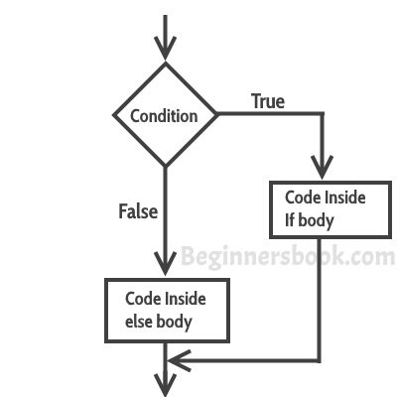

### Example of if else statement

In this program user is asked to enter the age and based on the input, the if..else statement checks whether the entered age is greater than or equal to 18. If this condition meet then display message “You are eligible for voting”, however if the condition doesn’t meet then display a different message “You are not eligible for voting”.

### Example #2: C if...else statement

// Program to check whether an integer entered by the user is odd or even

#include <stdio.h>

int main()

{

int number;

printf("Enter an integer: ");

scanf("%d",&number);

// True if remainder is 0

if( number%2 == 0 )

printf("%d is an even integer.",number);

else

printf("%d is an odd integer.",number);

return 0;

}

**Output**

Enter an integer: 7

7 is an odd integer.

**Nested if...else statement**

he if...else statement executes two different codes depending upon whether the test expression is true or false. Sometimes, a choice has to be made from more than 2 possibilities.

The nested if...else statement allows you to check for multiple test expressions and execute different codes for more than two conditions.

### Syntax of nested if...else statement.

if (testExpression1)

{

// statements to be executed if testExpression1 is true

}

else if(testExpression2)

{

// statements to be executed if testExpression1 is false and testExpression2 is true

}

else if (testExpression 3)

{

// statements to be executed if testExpression1 and testExpression2 is false and testExpression3 is true

}

.

.

else

{

// statements to be executed if all test expressions are false

}

### Example #3: C Nested if...else statement

// Program to relate two integers using =, > or <

#include <stdio.h>

int main()

{

int number1, number2;

printf("Enter two integers: ");

scanf("%d %d", &number1, &number2);

//checks if two integers are equal.

if(number1 == number2)

{

printf("Result: %d = %d",number1,number2);

}

//checks if number1 is greater than number2.

else if (number1 > number2)

{

printf("Result: %d > %d", number1, number2);

}

// if both test expression is false

else

{

printf("Result: %d < %d",number1, number2);

}

return 0;

}

**Output**

Enter two integers: 12

23

Result: 12 < 23

# C - switch statement

A **switch** statement allows a variable to be tested for equality against a list of values. Each value is called a case, and the variable being switched on is checked for each **switch case**.

## **Syntax**

The syntax for a **switch** statement in C programming language is as follows −

switch(expression) {

case constant-expression :

statement(s);

break; /* optional */

case constant-expression :

statement(s);

break; /* optional */

/* you can have any number of case statements */

default : /* Optional */

statement(s);

}

The following rules apply to a **switch** statement −

* The **expression** used in a **switch** statement must have an integral or enumerated type, or be of a class type in which the class has a single conversion function to an integral or enumerated type.
* You can have any number of case statements within a switch. Each case is followed by the value to be compared to and a colon.
* The **constant-expression** for a case must be the same data type as the variable in the switch, and it must be a constant or a literal.
* When the variable being switched on is equal to a case, the statements following that case will execute until a **break** statement is reached.
* When a **break** statement is reached, the switch terminates, and the flow of control jumps to the next line following the switch statement.
* Not every case needs to contain a **break**. If no **break** appears, the flow of control will *fall through* to subsequent cases until a break is reached.
* A **switch** statement can have an optional **default** case, which must appear at the end of the switch. The default case can be used for performing a task when none of the cases is true. No **break** is needed in the default case.

## **Flow Diagram**

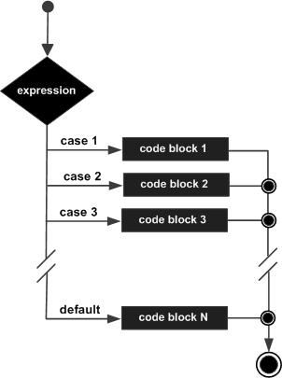

## **Example**

#include <stdio.h>

int main () {

/* local variable definition */

char grade = 'B';

switch(grade) {

case 'A' :

printf("Excellent!\n" );

break;

case 'B' :

case 'C' :

printf("Well done\n" );

break;

case 'D' :

printf("You passed\n" );

break;

case 'F' :

printf("Better try again\n" );

break;

default :

printf("Invalid grade\n" );

}

printf("Your grade is %c\n", grade );

return 0;

}

When the above code is compiled and executed, it produces the following result −

Well done

Your grade is B

**C Programming for Loop**

Loops are used in programming to repeat a specific block of code. After reading this tutorial, you will learn to create a for loop in C programming.

Loops are used in programming to repeat a specific block until some end condition is met. There are three loops in C programming:

1. for loop
2. [while loop](https://www.programiz.com/c-programming/c-do-while-loops)
3. [do...while loop](https://www.programiz.com/c-programming/c-do-while-loops)

**for Loop**

 The syntax of for loop is:

for (initializationStatement; testExpression; updateStatement)

{

// codes

}

**How for loop works?**

The initialization statement is executed only once.

Then, the test expression is evaluated. If the test expression is false (0), for loop is terminated. But if the test expression is true (nonzero), codes inside the body of for loop is executed and the update expression is updated.

This process repeats until the test expression is false.

The for loop is commonly used when the number of iterations is known.

To learn more on test expression (when test expression is evaluated to nonzero (true) and 0 (false)), check out [relational](https://www.programiz.com/c-programming/c-operators#relational) and [logical operators](https://www.programiz.com/c-programming/c-operators#logical).

**for loop Flowchart**

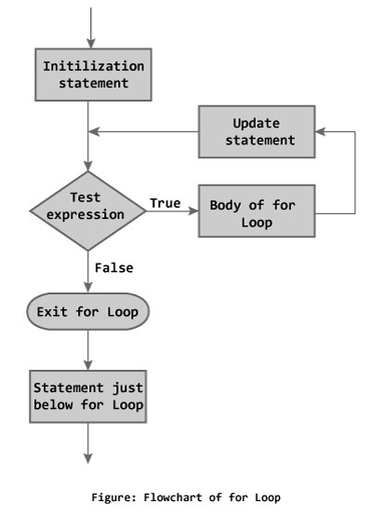

**Example: for loop**

// Program to calculate the sum of first n natural numbers

// Positive integers 1,2,3...n are known as natural numbers

#include <stdio.h>

int main()

{

int num, count, sum = 0;

printf("Enter a positive integer: ");

scanf("%d", &num);

// for loop terminates when n is less than count

for(count = 1; count <= num; ++count)

{

sum += count;

}

printf("Sum = %d", sum);

return 0;

}

**Output**

Enter a positive integer: 10

Sum = 55

The value entered by the user is stored in variable num. Suppose, the user entered 10.

The count is initialized to 1 and the test expression is evaluated. Since, the test expression count <= num (1 less than or equal to 10) is true, the body of for loop is executed and the value of sum will equal to 1.

Then, the update statement ++count is executed and count will equal to 2. Again, the test expression is evaluated. Since, 2 is also less than 10, the test expression is evaluated to true and the body of for loop is executed. Now, the sum will equal 3.

This process goes on and the sum is calculated until the count reaches 11.

When the count is 11,  the test expression is evaluated to 0 (false) as 11 is not less than or equal to 10. Therefore, the loop terminates and next, the total sum is printed.

## while loop

The syntax of a while loop is:

while (testExpression)

{

//codes

}

where, testExpression checks the condition is true or false before each loop.

### **How while loop works?**

The while loop evaluates the test expression.

If the test expression is true (nonzero), codes inside the body of while loop are exectued. The test expression is evaluated again. The process goes on until the test expression is false.

When the test expression is false, the while loop is terminated.

### **Flowchart of while loop**

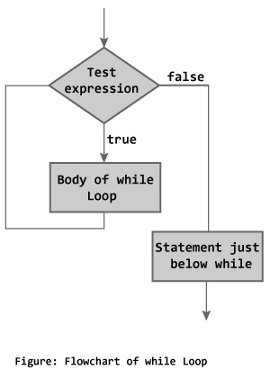

### **Example #1: while loop**

// Program to find factorial of a number

// For a positive integer n, factorial = 1*2*3...n

#include <stdio.h>

int main()

{

int number;

long long factorial;

printf("Enter an integer: ");

scanf("%d",&number);

factorial = 1;

// loop terminates when number is less than or equal to 0

while (number > 0)

{

factorial *= number; // factorial = factorial*number;

--number;

}

printf("Factorial= %lld", factorial);

return 0;

}

**Output**

Enter an integer: 5

Factorial = 120

To learn more on test expression (when test expression is evaluated to nonzero (true) and 0 (false)), check out [relational](https://www.programiz.com/c-programming/c-operators#relational) and [logical operators](https://www.programiz.com/c-programming/c-operators#logical).

## **do...while loop**

The do..while loop is similar to the while loop with one important difference. The body of do...while loop is executed once, before checking the test expression. Hence, the do...while loop is executed at least once.

### **do...while loop Syntax**

do

{

// codes

}

while (testExpression);

### **How do...while loop works?**

The code block (loop body) inside the braces is executed once.

Then, the test expression is evaluated. If the test expression is true, the loop body is executed again. This process goes on until the test expression is evaluated to 0 (false).

When the test expression is false (nonzero), the do...while loop is terminated.

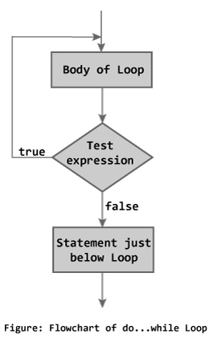

### **Example #2: do...while loop**

// Program to add numbers until user enters zero

#include <stdio.h>

int main()

{

double number, sum = 0;

// loop body is executed at least once

do

{

printf("Enter a number: ");

scanf("%lf", &number);

sum += number;

}

while(number != 0.0);

printf("Sum = %.2lf",sum);

return 0;

}

**Output**

Enter a number: 1.5

Enter a number: 2.4

Enter a number: -3.4

Enter a number: 4.2

Enter a number: 0

Sum = 4.70

# Functions in the C programming Language

# The C language is similar to most modern programming languages in that it allows the use of functions, self contained "modules" of code that take inputs, do a computation, and produce outputs. C functions must be TYPED (the return type and the type of all parameters specified).

# Functions in C

As always, a function is a module of code that takes information in (referring to that information with local symbolic names called parameters), does some computation, and (usually) returns a new piece of information based on the parameter information.

## Basic Function Design Pattern

For the basic syntax of a function in C, please refer to the C Function Design Pattern chapter.

## Dot C files

The "recipe" for a function (the function's code) is always stored in a ".C" file. In C there can be many functions written in a single file.

## Ordering of functions in a file

The order of functions inside a file is arbitrary. It **does not matter** if you put function one at the top of the file and function two at the bottom, or vice versa.

***Caveat:****In order for one function to "see" (use) another function, the "prototype" of the function must be seen in the file before the usage. If a function uses another function that is textually written above it in the file, then this will automatically be true. If the function uses a function that is "below it" in a file, then the prototype should occur at the top of the file... see prototypes below.*

## **A Function Prototype**

In C, all functions must be written to return a specific TYPE of information and to take in specific types of data (parameters). This information is communicated to the compiler via a function prototype.

Here is the syntax for the function declaration or **Prototype**:

          RETURN_TYPE name_of_function ( PARAMETER_TYPE name_of_param,PARAMETER_TYPE name_of_param, etc);   
   
          // here are some examples of prototypes used at the top of a file:   
          float sqrt( float x );   
   
          float average( int grades[], int length ); 

A Prototype can occur at the top of a C source code file to describe what the function returns and what it takes (return type and parameter list). When this is the case (occuring at the top of the file), the function prototype **should be followed by a semi-colon**

The function prototype is also used at the beginning of the code for the function. Thus the prototype **can occur twice**in a C source code file. When the prototype occurs with the code **NO semicolon is used**.

## **The Main Function**

In C, the "main" function is treated the same as every function, it has a return type (and in some cases accepts inputs via parameters). The only difference is that the main function is "called" by the operating system when the user runs the program. Thus the main function is always the first code executed when a program starts.

   
 int                       // the main function will usually returns a 0 if successful   
 main()                    // this is the name, in this case: main   
 {   
                           // this is the body of the function (lots of code can go here)   
 } 

**Examples of C Functions:**

   
 double                                 // this is the return type    
 max( double param1, double param2)     // this is the name, followed by the parameters   
 {   
   **if** (param1 > param2)   
     {   
       **return** param1;  // Notice: that param1 is of type double and the return   
                       //         type is also of type double   
     }   
   **else**   
     {   
       **return** param2;   
     }   
 }   
   
   
   
**void**         // This is the return type (void means no value is computed and returned by the function!)   
print_happy_birthday( int age )   
{   
   printf("Congratulations on your %d th Birthday\n", age);   
   **return**;  // you can "terminate" a void function by using return.   
   // HERE it is REDUNDANT because the function is over anyway.   
} 

## Return Type of a C function

Every C function must specify the type of data that is being generated. For example, the max function above returns a value of type "double". Inside the function, the line "return X;" must be found, where X is a value or variable containing a value of the given type.

### The return statement

When a line of code in a function that says: "return X;" is executed, the function "ends" and no more code in the function is executed. The value of X (or the value in the variable represented by X) becomes the result of the function.

## Calling a C function (aka invoke a function)

When one piece of code invokes or calls a function, it is done by the following syntax:

           
        variable = function_name ( args, ...);   
         

The function name must match exactly the name of the function in the function prototype. The args are a list of values (or variables containing values) that are "passed" into the function.

The number of args "passed" into a function **must exactly match** the number of parameters required for the function. The type of each arg **must exactly match** the type of each parameter. The return variable type **must exactly match** the return type of the function.

The "variable" in the example above must have a type equivalent to the return type of the function. Inside the function, somewhere will be the line "return X". The value of X is then copied into the "variable".

## **Parameters in C functions**

A Parameter is the symbolic name for "data" that goes into a function. There are two ways to pass parameters in C: Pass by Value, Pass by Reference.

### Pass by Value

Pass by Value, means that a copy of the data is made and stored by way of the name of the parameter. Any changes to the parameter have **NO** affect on data in the calling function.

### Pass by Reference

A **reference parameter** "refers" to the original data in the calling function. Thus any changes made to the parameter are **ALSO MADE TO THE ORIGINAL** variable.

There are two ways to make a pass by reference parameter:

**ARRAYS**

Arrays are **always** pass by reference in C. Any change made to the parameter containing the array will change the value of the original array.

* 1. The ampersand used in the function prototype.

function (**& parameter_name )**

To make a normal parameter into a pass by reference parameter, we use the "& param" notation. The ampersand (&) is the syntax to tell C that any changes made to the parameter also modify the original variable containing the data.

## **Pass by Value Example:**

In C, the default is to pass by value. For example:

   
        //   
        // C function using pass by value. (Notice no &)   
        //   
        **void**   
        doit( int x )   
        {   
             x = 5;   
        }   
   
        //   
        // Test function for passing by value (i.e., making a copy)   
        //   
        int   
        main()   
        {   
          int z = 27;   
          doit( z );   
          printf("z is now %d\n", z);   
   
          **return** 0;   
        } 

## Pass by Reference Example:

**Again, remember the Syntax is to use the '&' in front of the variable**. For example:

   
        //   
        // C using Reference Parameter!   
        //   
        **void**   
        doit( int & x )   
        {   
             x = 5;   
        }   
   
   
        //   
        // Test code for passing by a variable by reference   
        //   
        int   
        main()   
        {   
          int z = 27;   
          doit( z );   
          printf("z is now %d\n", z);   
   
          **return** 0;   
        } 

In summary, if you use a reference parameter, any changes to the parameter inside the function are reflected "outside" of the function! If you don't use the & (pass by reference), then we get the same behavior as in Matlab.

Reference parameters are used to make programs more "efficient". Consider passing in a structure as a parameter. If the structure is very big, and we copy all of it, then we are using a lot of unnecessary memory.

## Array Parameter Example (ALWAYS pass by reference)

Arrays are always **passed by reference** in C. They **do not** use the '&' notation, but are pass by reference none the less. For example:

   
        //   
        // Initialize an array with values 1,2,3,...,length_of_array   
        //   
        // Notice: Any changes made to "array_variable" are reflected in   
        //         the calling code! Arrays are pass by reference!   
        //   
        // Notice: There is no return statement, but still the array is changed   
        //         and can be said to be "returned" to the calling function.   
        //   
        **void**   
        build_array( int array_variable[], int length_of_array )   
        {   
            **for** (int i=0; i<length_of_array; i++)   
              {   
                array_variable[i] = i;   
              }   
        }   
   
   
        //   
        // Test code for passing an array by reference   
        //   
        int   
        main()   
        {   
          int values[50];   
   
          printf("the value at location 7 starts as %d\n", values[7]);   
   
          build_array(values, 50);   
   
          printf("the value at location 7 is now %d\n", values[7]);   
   
          **return** 0;   
        } 

## **Constant Reference**

To protect from accidentally changing a reference parameter, when we really want it not to be changed (we just want to save time/memory) we can use the C keyword **const**. For example:

   
        //   
        // C Code using a CONSTANT reference Parameter   
        //   
        **void**   
        doit( **const** int & x )   
        {   
            x = 5; // ILLEGAL   
        }   
   
        //   
        // Main Function   
        //   
        int   
        main()   
        {   
          int z = 27;   
          doit( z );   
          printf("z is now %d\n", z);   
   
          **return** 0;   
        } 

## **Void Functions**

If a function does not return a value, then a special "TYPE" is used to tell the computer this. The return type is "void" (all lower case).

Void functions are mostly used in two classes of functions.

1. The first is a function that prints information for the user to read. For example (for our purposes), the printf function is treated as a void function. (In actuality, printf returns an integer which is the number of characters printed... but we almost always ignore this value.)
2. The second use of void functions is with "reference" parameters (e.g., Arrays). A reference parameter is **not** a copy of the input data, as is so often the case. A reference parameter is an "alias" for the same bucket in memory as the input data. Thus any change made to a reference parameter **is in fact made to the original variable!**

# C Programming Pointers

In this article, you'll learn about pointers; what are they, how do you use them and the common mistakes you might face when working with them.

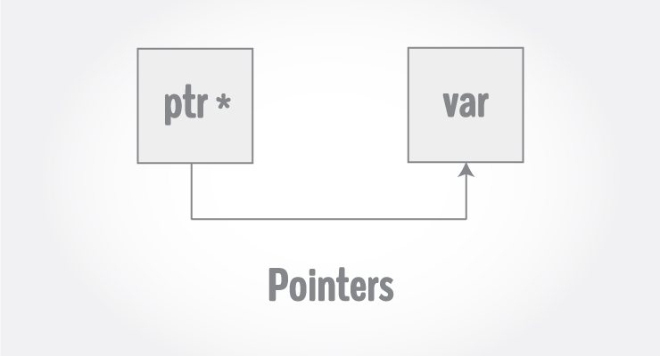

Pointers are powerful features of C and (C++) programming that differentiates it from other popular programming languages like: Java and Python.

Pointers are used in C program to access the memory and manipulate the address.

## **Address in C**

Before you get into the concept of pointers, let's first get familiar with address in C.

If you have a variable var in your program, &var will give you its address in the memory, where & is commonly called the reference operator.

You must have seen this notation while using scanf() function. It was used in the function to store the user inputted value in the address of var.

scanf("%d", &var);

/* Example to demonstrate use of reference operator in C programming. */

#include <stdio.h>

int main()

{

int var = 5;

printf("Value: %d\n", var);

printf("Address: %u", &var); //Notice, the ampersand(&) before var.

return 0;

}

**Output**

Value: 5

Address: 2686778

**Note:** You may obtain different value of address while using this code.

In above source code, value 5 is stored in the memory location 2686778. var is just the name given to that location.

## **Pointer variables**

In C, there is a special variable that stores just the address of another variable. It is called Pointer variable or, simply, a pointer.

Declaration of Pointer

data_type* pointer_variable_name;

int* p;

Above statement defines, p as pointer variable of type int.

### **Reference operator (&) and Dereference operator (*)**

As discussed, & is called reference operator. It gives you the address of a variable.

Likewise, there is another operator that gets you the value from the address, it is called a dereference operator (*).

Below example clearly demonstrates the use of pointers, reference operator and dereference operator.

**Note:** The * sign when declaring a pointer is not a dereference operator. It is just a similar notation that creates a pointer.

### **Example To Demonstrate Working of Pointers**

/* Source code to demonstrate, handling of pointers in C program */

#include <stdio.h>

int main(){

int* pc;

  int c;

c=22;

printf("Address of c:%u\n",&c);

printf("Value of c:%d\n\n",c);

pc=&c;

printf("Address of pointer pc:%u\n",pc);

printf("Content of pointer pc:%d\n\n",*pc);

c=11;

printf("Address of pointer pc:%u\n",pc);

printf("Content of pointer pc:%d\n\n",*pc);

*pc=2;

printf("Address of c:%u\n",&c);

printf("Value of c:%d\n\n",c);

return 0;

}

**Output**

Address of c: 2686784

Value of c: 22

Address of pointer pc: 2686784

Content of pointer pc: 22

Address of pointer pc: 2686784

Content of pointer pc: 11

Address of c: 2686784

Value of c: 2

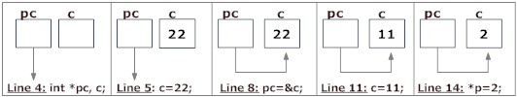

**Explanation of program and figure**

1. int* pc; creates a pointer pc and int c; creates a normal variable c.  
   Since pc and c are both not initialized, pointer pc points to either no address or a random address. Likewise, variable c is assigned an address but contains a random/garbage value.
2. c=22; assigns 22 to the variable c, i.e.,22 is stored in the memory location of variable c.  
   Note that, when printing &c (address of c), we use %u rather than %d since address is usually expressed as an unsigned integer (always positive).
3. pc=&c; assigns the address of variable to c to the pointer pc.  
   When printing, you see value of pc is the same as the address of c and the content of pc (*pc) is 22 as well.
4. c=11; assigns 11 to variable c.  
   We assign a new value to c to see its effect on pointer pc.
5. Since, pointer pc points to the same address as c, value pointed by pointer pc is 11 as well.  
   Printing the address and content of pc shows the updated content as 11.
6. *pc=2; changes the contents of the memory location pointed by pointer pc to 2.  
   Since the address of pointer pc is same as address of c, value of c also changes to 2.

#### **Common mistakes when working with pointers**

Suppose, you want pointer pc to point to the address of c. Then,

int c, *pc;

// Wrong! pc is address whereas, c is not an address.

pc = c;

// Wrong! *pc is the value pointed by address whereas, %amp;c is an address.

*pc = &c;

// Correct! pc is an address and, %amp;pc is also an address.

pc = &c;

// Correct! *pc is the value pointed by address and, c is also a value.

*pc = c;

In both cases, pointer pc is not pointing to the address of c.

# File Handling in C

So far the operations using C program are done on a prompt / terminal which are not stored anywhere. But in software industry, most of the programs are written to store the information fetched from the program. One such way is to store the fetched information in a file. Different operations that can be performed on a file are:

1. Creation of a new file (fopen with attributes as “a” or “a+” or “w” or “w++”)
2. Opening an existing file (fopen)
3. Reading from file (fscanf or fgetc)
4. Writing to a file (fprintf or fputs)
5. Moving to a specific location in a file (fseek, rewind)
6. Closing a file (fclose)

The text in the brackets denotes the functions used for performing those operations.

**Opening or creating file –**

For opening a file, fopen function is used with the required access modes. Some of the commonly used file access modes are:

* **“r” –** Searches file. If the file is opened successfully fopen( ) loads it into memory and sets up a pointer which points to the first character in it. If the file cannot be opened fopen( ) returns NULL.
* **“w” –** Searches file. If the file exists, its contents are overwritten. If the file doesn’t exist, a new file is created. Returns NULL, if unable to open file.
* **“a” –** Searches file. If the file is opened successfully fopen( ) loads it into memory and sets up a pointer that points to the last character in it. If the file doesn’t exist, a new file is created. Returns NULL, if unable to open file.
* **“r+” –** Searches file. If is opened successfully fopen( ) loads it into memory and sets up a pointer which points to the first character in it. Returns NULL, if unable to open the file.
* **“w+” –** Searches file. If the file exists, its contents are overwritten. If the file doesn’t exist a new file is created. Returns NULL, if unable to open file.
* **“a+” –** Searches file. If the file is opened successfully fopen( ) loads it into memory and sets up a pointer which points to the last character in it. If the file doesn’t exist, a new file is created. Returns NULL, if unable to open file.

As given above, if you want to perform operations on binary file, then you have to append ‘b’ at the last. For example, instead of “w” you have to use “wb”, insead of “a+” you have to use “a+b”. For performig the operations on file, a special pointer called File pointer is used which is decalared as

FILE *fp;

So, the file can be opened as

fp = fopen(“fileName.txt”, “w”)

The second parameter can be changed to contain all the attributes listed in the above table.

**Reading from a file –**

The file read operations can be perfomed using functions fscanf or fgets. Both the functions performd the same operations as that of printf and gets but with an additional parameter, the file pointer. So, it depends on you if you want to read the file line by line or character by character.

And the code snippet for reading a file is as:

FILE * fp;

fp = fopen(“fileName.txt”, “r”);

fscanf(fp, "%s %s %s %d", str1, str2, str3, &year);

**Writing a file –**:

The file write operations can be perfomed by the functions fprintf and fputs with similarities to read operations. The snippet for writing to a file is as :

FILE *fp ;

fp = fopen(“fileName.txt”, “w”);

fprintf(fp, "%s %s %s %d", "We", "are", "in", 2012);

**Closing a file –**:

After every successful fie operations, you must always close a file. For closing a file, you have to use fclose function. The snippet for closing a file is given as :

FILE *fp ;

fp= fopen(“fileName.txt”, “w”);

---------- Some file Operations -------

fclose(fp)

**Algorithm**

1. Start.

2. The program will show the main menu.

3. It asks user to choose departure and destination flight

3.1. Narathiwat (NAW) to Suwannaphum (BKK).

3.2. Hat Yai (HDY) to Don Muang(DMK).

3.3. Narathiwat (NAW) to Phuket (HKT).

3.4. Don Muang(DMK) to Hat Yai (HDY).

4. If user enter another numbers that given, it will ask user to enter again.

5. It will display your chosen flight.

6. It will ask user to choose airline.

7. It will ask user to enter number of passenger.

8. It will ask user to input information for booking.

9. It will calculate price with number of passenger and airline then display all booking details.

10. It will ask user to confirm booking.

11. If user select **No**, it will back to the details page. If user select **Yes**, it will show

reserved page.

12. Stop.

**Source Code**

#include<stdio.h>

#include<string.h>

#include<conio.h>

#include<stdlib.h>

#include<windows.h>

#include<time.h>

#define MAX 20

int menu();

int t(void);

void list();

void air1();

void air2();

void air3();

void air4();

void confirm();

void been();

int main(){

menu();

return 0;

}

int menu(){

system("cls");

system("COLOR 0F");

printf("\n\n\t\t-----------------------------------------------------------------------\n");

printf("\t\t === \t\tWELCOME TO AIRLINES RESERVATION SYSTEM\t\t ===");

printf("\n\t\t-------------------------------******----------------------------------");

printf("\n\n\t\t\t\t\t FLIGHT DESTINATION");

printf("\n\n\n\t\t\t\t1.DEPARTURE ");

printf("\n\n\t\t\t\t2.DESTINATION \n");

printf("\n\t\t === \t\t \t\t ===");

t();

printf("\t\t-----------------------------------------------------------------------");

printf("\n\t\t \tCREDIT : HARISYUNUH");

printf("\n\t\tPRESS 1 TO SEE MENU : ");

switch(getch()){

case'1':list();

break;

default:menu();

break;

}

return 0;

}

void list(){

system("cls");

int flight;

printf("\n\n\t\t-----------------------------------------------------------------\n");

printf("\t\t === \t\t AIRLINES RESERVATION SYSTEM\t\t ===");

printf("\n\t\t\t\t\tCITIES/AIRPORTS \t\t");

printf("\n\n\t\tChoose Departure and Destination Flight :");

printf("\n\n\t\t\t 1. Narathiwat (NAW)\t -->\t Suwannaphum (BKK)");

printf("\n\n\t\t\t 2. Hat Yai (HDY)\t -->\t Don Muang (DMK)");

printf("\n\n\t\t\t 3. Narathiwat (NAW)\t -->\t Phuket (HKT)");

printf("\n\n\t\t\t 4. Don Muang(DMK)\t -->\t Hat Yai (HDY)");

printf("\n\n\t\t === \t\t \t\t ===");

printf("\t\t-----------------------------------------------------------------");

printf("\n\t\tENTER THE NUMBER TO CHOOSE DEPARTURE AND DESTINATION FLIGHT : ");

scanf("%d",&flight);

system("cls");

if (flight==1){

printf("\n\n\t\t-----------------------------------------------------------------\n");

printf("\t\t === \t\t AIRLINES RESERVATION SYSTEM\t\t ===");

printf("\n\t\t\t\t\tFLIGHT DESTINATION");

printf("\n\n\n\n\t\t\t\t DEPARTURE :\tNarathiwat (NAW)");

printf("\n\n\n\t\t\t\t DESTINATION :\tSuwannaphum (BKK)");

printf("\n\n\t\t === \t\t \t\t ===");

printf("\n\t\t-----------------------------------------------------------------");

printf("\n\t\t\t PRESS N TO RETURN | PRESS Y TO CONTINUE : ");

switch(getch()){

case'y':air1();

break;

default:list();

break;

}

}

else if (flight==2){

printf("\n\n\t\t-----------------------------------------------------------------\n");

printf("\t\t === \t\t AIRLINES RESERVATION SYSTEM\t\t ===");

printf("\n\t\t\t\t\tFLIGHT DESTINATION");

printf("\n\n\n\n\t\t\t\t DEPARTURE :\tHat Yai (HDY)");

printf("\n\n\n\t\t\t\t DESTINATION :\tDon Muang(DMK)");

printf("\n\n\t\t === \t\t \t\t ===");

printf("\n\t\t-----------------------------------------------------------------");

printf("\n\t\t\t PRESS N TO RETURN | PRESS Y TO CONTINUE : ");

switch(getch()){

case'y':air2();

break;

default:list();

break;

}

}

else if (flight==3){

printf("\n\n\t\t-----------------------------------------------------------------\n");

printf("\t\t === \t\t AIRLINES RESERVATION SYSTEM\t\t ===");

printf("\n\t\t\t\t\tFLIGHT DESTINATION");

printf("\n\n\n\n\t\t\t\t DEPARTURE :\tNarathiwat (NAW)");

printf("\n\n\n\t\t\t\t DESTINATION :\tPhuket (HKT)");

printf("\n\n\t\t === \t\t \t\t ===");

printf("\n\t\t-----------------------------------------------------------------");

printf("\n\t\t\t PRESS N TO RETURN | PRESS Y TO CONTINUE : ");

switch(getch()){

case'y':air3();

break;

default:list();

break;

}

}

else if (flight==4){

printf("\n\n\t\t-----------------------------------------------------------------\n");

printf("\t\t === \t\t AIRLINES RESERVATION SYSTEM\t\t ===");

printf("\n\t\t\t\t\tFLIGHT DESTINATION");

printf("\n\n\n\n\t\t\t\t DEPARTURE :\tDon Muang(DMK)");

printf("\n\n\n\t\t\t\t DESTINATION :\tHat Yai (HDY)");

printf("\n\n\t\t === \t\t \t\t ===");

printf("\n\t\t-----------------------------------------------------------------");

printf("\n\t\t\t PRESS N TO RETURN | PRESS Y TO CONTINUE : ");

switch(getch()){

case'y':air4();

break;

default:list();

break;

}

}

else {

list();

}

}

void air1(){

system("cls");

int num1,

airasia=990,

nokair=1190,

thailionair=1260,

hr1=7,

min1=30,

hr2=9,

min2=45,

hr3=11,

min3=15;

system("cls");

printf("\n\n\t\t-----------------------------------------------------------------\n");

printf("\t\t === \t\t AIRLINES RESERVATION SYSTEM\t\t ===");

printf("\n\t\t\t\t\tSEARCH FLIGHTS");

printf("\n\n\n\t\t FLIGHT: TIME: PRICE(BAHT):");

printf("\n\n\n\t\t1. AIR ASIA\t\t\t%d:%d AM.\t\t%d.-", hr1, min1, airasia);

printf("\n\n\t\t2. NOK AIR\t\t\t%d:%d AM.\t\t%d.-", hr2, min2, nokair);

printf("\n\n\t\t3. THAI LION AIR\t\t%d:%d AM.\t\t%d.-", hr3, min3, thailionair);

printf("\n\n\t\t === \t\t \t\t ===");

printf("\n\t\t-----------------------------------------------------------------");

printf("\n\t\tENTER THE NUMBER FLIGHT : ");

scanf("%d",&num1);

printf("\n\t\tPRESS ENTER TO CONTINUE !! ");

getch();

if (num1==1) {

system("cls");

printf("\n\n\t\t-----------------------------------------------------------------\n");

printf("\t\t === \t\t AIRLINES RESERVATION SYSTEM\t\t ===");

printf("\n\t\t\t\t\tSEARCH FLIGHTS");

printf("\n\t\tNarathiwat (NAW)\t -->\t Suwannaphum (BKK)");

printf("\n\n\n\t\t FLIGHT: TIME: PRICE(BAHT):");

printf("\n\n\n\t\t AIR ASIA\t\t\t%d:%d AM.\t\t%d.-", hr1, min1, airasia);

printf("\n\n\t\t === \t\t \t\t ===");

printf("\n\t\t-----------------------------------------------------------------");

printf("\n\t\tPRESS ENTER TO CONTINUE !! ");

getch();

system("cls");

char firstname[MAX], lastname[MAX], national[MAX], email[MAX], contect[MAX], birthdate[MAX],flydate[MAX];

int phonenumber;

printf("\n\n\t\t-----------------------------------------------------------------\n");

printf("\t\t === \t\t AIRLINES RESERVATION SYSTEM\t\t ===");

printf("\n\t\t\t\t\tCONTECT INFORMATION : ");

printf("\n\n\t\t\tFIRST NAME : ");

scanf("%s", &firstname);

printf("\t\t\tLAST NAME : ");

scanf("%s", &lastname);

printf("\n\t\t\tDATE OF BIRTH : ");

scanf("%s", &birthdate);

printf("\n\t\t\tNATIONAL : ");

scanf("%s", &national);

printf("\n\t\t\tMOBILE PHONE NUMBER : ");

scanf("%d", &phonenumber);

printf("\n\t\t\tDATE TO FLY(DD/MM/YYYY) : ");

scanf("%s", &flydate);

printf("\n\t\t\tEMAIL : ");

scanf("%s", &email);

printf("\n\n\t\t === \t\t \t\t ===");

printf("\n\t\t-----------------------------------------------------------------");

printf("\n\t\tPRESS ENTER TO CONTINUE !! ");

getch();

system("cls");

printf("\n\n\t\t-----------------------------------------------------------------\n");

printf("\t\t === \t\t AIRLINES RESERVATION SYSTEM\t\t ===");

printf("\n\t\t\t\t\tDETAILS : ");

printf("\n\n\t\tFLIGHT : Narathiwat (NAW)\t -->\t Suwannaphum (BKK)");

printf("\n\t\tTIME : %d:%d PM.",hr1, min1);

printf("\n\t\tDATE TO FLY : %s",flydate);

printf("\n\n\n\t\tFIRST NAME : %s",firstname);

printf("\t\tLAST NAME : %s",lastname);

printf("\n\t\tDATE OF BIRTH : %s",birthdate);

printf("\t\tNATIONAL : %s",national);

printf("\n\t\t MOBILE PHONE NUMBER : %d",phonenumber);

printf("\n\t\t EMAIL ADDRESS : %s",email);

printf("\n\n\t\t\tAIR ASIA");

printf("\n\n\n\t\t\t\t\t\t\t\t PRICE : %d BAHT",airasia);

printf("\n\n\t\t === \t\t \t\t ===");

printf("\n\t\t-----------------------------------------------------------------");

printf("\n\t\t\tPRESS ENTER TO CONTINUE !! ");

switch (getch()){

default : confirm();break;

}

}

else if (num1==2) {

system("cls");

printf("\n\n\t\t-----------------------------------------------------------------\n");

printf("\t\t === \t\t AIRLINES RESERVATION SYSTEM\t\t ===");

printf("\n\t\t\t\t\tSEARCH FLIGHTS");

printf("\n\n\n\t\t FLIGHT: TIME: PRICE(BAHT):");

printf("\n\n\n\t\t NOK AIR\t\t\t%d:%d AM.\t\t%d.-", hr2, min2, nokair);

printf("\n\n\t\t === \t\t \t\t ===");

printf("\n\t\t-----------------------------------------------------------------");

printf("\n\t\tPRESS ENTER TO CONTINUE !! ");

getch();

system("cls");

char firstname2[MAX], lastname2[MAX], national2[MAX], email2[MAX], contect2[MAX], birthdate2[MAX],flydate2[MAX];

int phonenumber2;

printf("\n\n\t\t-----------------------------------------------------------------\n");

printf("\t\t === \t\t AIRLINES RESERVATION SYSTEM\t\t ===");

printf("\n\t\t\t\t\tCONTECT INFORMATION : ");

printf("\n\n\t\t\tFIRST NAME : ");

scanf("%s", &firstname2);

printf("\t\t\tLAST NAME : ");

scanf("%s", &lastname2);

printf("\n\t\t\tDATE OF BIRTH : ");

scanf("%s", &birthdate2);

printf("\n\t\t\tNATIONAL : ");

scanf("%s", &national2);

printf("\n\t\t\tMOBILE PHONE NUMBER : ");

scanf("%d", &phonenumber2);

printf("\n\t\t\tDATE TO FLY(DD/MM/YYYY) : ");

scanf("%s", &flydate2);

printf("\n\t\t\tEMAIL : ");

scanf("%s", &email2);

printf("\n\n\t\t === \t\t \t\t ===");

printf("\n\t\t-----------------------------------------------------------------");

printf("\n\t\tPRESS ENTER TO CONTINUE !! ");

getch();

system("cls");

printf("\n\n\t\t-----------------------------------------------------------------\n");

printf("\t\t === \t\t AIRLINES RESERVATION SYSTEM\t\t ===");

printf("\n\t\t\t\t\tDETAILS : ");

printf("\n\n\t\tFLIGHT : Narathiwat (NAW)\t -->\t Suwannaphum (BKK)");

printf("\n\t\tTIME : %d:%d PM.",hr2, min2);

printf("\n\t\tDATE TO FLY : %s",flydate2);

printf("\n\n\n\t\tFIRST NAME : %s",firstname2);

printf("\t\tLAST NAME : %s",lastname2);

printf("\n\t\tDATE OF BIRTH : %s",birthdate2);

printf("\t\tNATIONAL : %s",national2);

printf("\n\t\t MOBILE PHONE NUMBER : %d",phonenumber2);

printf("\n\t\t EMAIL ADDRESS : %s",email2);

printf("\n\n\t\t\tNOK AIR");

printf("\n\n\n\t\t\t\t\t\t\t\t PRICE : %d BAHT",nokair);

printf("\n\n\t\t === \t\t \t\t ===");

printf("\n\t\t-----------------------------------------------------------------");

printf("\n\t\t\tPRESS ENTER TO CONTINUE !! ");

switch (getch()){

default : confirm();break;

}

}

else if (num1==3) {

system("cls");

printf("\n\n\t\t-----------------------------------------------------------------\n");

printf("\t\t === \t\t AIRLINES RESERVATION SYSTEM\t\t ===");

printf("\n\t\t\t\t\tSEARCH FLIGHTS");

printf("\n\n\n\t\t FLIGHT: TIME: PRICE(BAHT):");

printf("\n\n\n\t\t THAI LION AIR\t\t%d:%d AM.\t\t%d.-", hr3, min3, thailionair);

printf("\n\n\t\t === \t\t \t\t ===");

printf("\n\t\t-----------------------------------------------------------------");

printf("\n\t\tPRESS ENTER TO CONTINUE !! ");

getch();

system("cls");

char firstname3[MAX], lastname3[MAX], national3[MAX], email3[MAX], contect3[MAX], birthdate3[MAX],flydate3[MAX];

int phonenumber3;

printf("\n\n\t\t-----------------------------------------------------------------\n");

printf("\t\t === \t\t AIRLINES RESERVATION SYSTEM\t\t ===");

printf("\n\t\t\t\t\tCONTECT INFORMATION : ");

printf("\n\n\t\t\tFIRST NAME : ");

scanf("%s", &firstname3);

printf("\t\t\tLAST NAME : ");

scanf("%s", &lastname3);

printf("\n\t\t\tDATE OF BIRTH : ");

scanf("%s", &birthdate3);

printf("\n\t\t\tNATIONAL : ");

scanf("%s", &national3);

printf("\n\t\t\tMOBILE PHONE NUMBER : ");

scanf("%d", &phonenumber3);

printf("\n\t\t\tDATE TO FLY(DD/MM/YYYY) : ");

scanf("%s", &flydate3);

printf("\n\t\t\tEMAIL : ");

scanf("%s", &email3);

printf("\n\n\t\t === \t\t \t\t ===");

printf("\n\t\t-----------------------------------------------------------------");

printf("\n\t\tPRESS ENTER TO CONTINUE !! ");

getch();

system("cls");

printf("\n\n\t\t-----------------------------------------------------------------\n");

printf("\t\t === \t\t AIRLINES RESERVATION SYSTEM\t\t ===");

printf("\n\t\t\t\t\tDETAILS : ");

printf("\n\n\t\tFLIGHT : Narathiwat (NAW)\t -->\t Suwannaphum (BKK)");

printf("\n\t\tTIME : %d:%d PM.",hr3, min3);

printf("\n\t\tDATE TO FLY : %s",flydate3);

printf("\n\n\n\t\tFIRST NAME : %s",firstname3);

printf("\t\tLAST NAME : %s",lastname3);

printf("\n\t\tDATE OF BIRTH : %s",birthdate3);

printf("\t\tNATIONAL : %s",national3);

printf("\n\t\t MOBILE PHONE NUMBER : %d",phonenumber3);

printf("\n\t\t EMAIL ADDRESS : %s",email3);

printf("\n\n\t\t\tTHAI LION AIR");

printf("\n\n\n\t\t\t\t\t\t\t\t PRICE : %d BAHT",thailionair);

printf("\n\n\t\t === \t\t \t\t ===");

printf("\n\t\t-----------------------------------------------------------------");

printf("\n\t\t\tPRESS ENTER TO CONTINUE !! ");

switch (getch()){

default : confirm();break;

}

}

}

void air2(){

system("cls");

int num2,

airasia=750,

nokair=990,

thailionair=1225,

bangkokairways=1590,

thaiairways=1690,

hr1=7,

min1=30,

hr2=9,

min2=45,

hr3=11,

min3=15,

hr4=1,

min4=30,

hr5=4,

min5=45,

hr6=7,

min6=30;

system("cls");

printf("\n\n\t\t-----------------------------------------------------------------\n");

printf("\t\t === \t\t AIRLINES RESERVATION SYSTEM\t\t ===");

printf("\n\t\t\t\t\tSEARCH FLIGHTS");

printf("\n\n\n\t\t FLIGHT: TIME: PRICE(BAHT):");

printf("\n\n\n\t\t1. AIR ASIA\t\t\t%d:%d AM.\t\t%d.-", hr1, min1, airasia);

printf("\n\n\t\t2. NOK AIR\t\t\t%d:%d AM.\t\t%d.-", hr2, min2, nokair);

printf("\n\n\t\t3. THAI LION AIR\t\t%d:%d AM.\t\t%d.-", hr3, min3, thailionair);

printf("\n\n\t\t4. BANGKOK AIRWAYS\t\t%d:%d PM.\t\t%d.-", hr5, min5, bangkokairways);

printf("\n\n\t\t5. THAI AIRWAYS\t\t\t%d:%d PM.\t\t%d.-", hr6, min6, thaiairways);

printf("\n\n\t\t === \t\t \t\t ===");

printf("\n\t\t-----------------------------------------------------------------");

printf("\n\t\tENTER THE NUMBER FLIGHT : ");

scanf("%d",&num2);

printf("\n\t\tPRESS ENTER TO CONTINUE !! ");

getch();

if (num2==1) {

system("cls");

printf("\n\n\t\t-----------------------------------------------------------------\n");

printf("\t\t === \t\t AIRLINES RESERVATION SYSTEM\t\t ===");

printf("\n\t\t\t\t\tSEARCH FLIGHTS");

printf("\n\t\tHat Yai (HDY)\t -->\t Don Muang(DMK)");

printf("\n\n\n\t\t FLIGHT: TIME: PRICE(BAHT):");

printf("\n\n\n\t\t AIR ASIA\t\t\t%d:%d AM.\t\t%d.-", hr1, min1, airasia);

printf("\n\n\t\t === \t\t \t\t ===");

printf("\n\t\t-----------------------------------------------------------------");

printf("\n\t\tPRESS ENTER TO CONTINUE !! ");

getch();

system("cls");

char firstname[MAX], lastname[MAX], national[MAX], email[MAX], contect[MAX], birthdate[MAX],flydate[MAX];

int phonenumber;

printf("\n\n\t\t-----------------------------------------------------------------\n");

printf("\t\t === \t\t AIRLINES RESERVATION SYSTEM\t\t ===");

printf("\n\t\t\t\t\tCONTECT INFORMATION : ");

printf("\n\n\t\t\tFIRST NAME : ");

scanf("%s", &firstname);

printf("\t\t\tLAST NAME : ");

scanf("%s", &lastname);

printf("\n\t\t\tDATE OF BIRTH : ");

scanf("%s", &birthdate);

printf("\n\t\t\tNATIONAL : ");

scanf("%s", &national);

printf("\n\t\t\tMOBILE PHONE NUMBER : ");

scanf("%d", &phonenumber);

printf("\n\t\t\tDATE TO FLY(DD/MM/YYYY) : ");

scanf("%s", &flydate);

printf("\n\t\t\tEMAIL : ");

scanf("%s", &email);

printf("\n\n\t\t === \t\t \t\t ===");

printf("\n\t\t-----------------------------------------------------------------");

printf("\n\t\tPRESS ENTER TO CONTINUE !! ");

getch();

system("cls");

printf("\n\n\t\t-----------------------------------------------------------------\n");

printf("\t\t === \t\t AIRLINES RESERVATION SYSTEM\t\t ===");

printf("\n\t\t\t\t\tDETAILS : ");

printf("\n\n\t\tFLIGHT : Hat Yai (HDY)\t -->\t Don Muang(DMK)");

printf("\n\t\tTIME : %d:%d PM.",hr1, min1);

printf("\n\t\tDATE TO FLY : %s",flydate);

printf("\n\n\n\t\tFIRST NAME : %s",firstname);

printf("\t\tLAST NAME : %s",lastname);

printf("\n\t\tDATE OF BIRTH : %s",birthdate);

printf("\t\tNATIONAL : %s",national);

printf("\n\t\t MOBILE PHONE NUMBER : %d",phonenumber);

printf("\n\t\t EMAIL ADDRESS : %s",email);

printf("\n\n\t\t\t AIR ASIA");

printf("\n\n\n\t\t\t\t\t\t\t\t PRICE : %d BAHT",airasia);

printf("\n\n\t\t === \t\t \t\t ===");

printf("\n\t\t-----------------------------------------------------------------");

printf("\n\t\t\tPRESS ENTER TO CONTINUE !! ");

switch (getch()){

default : confirm();break;

}

}

else if (num2==2) {

system("cls");

printf("\n\n\t\t-----------------------------------------------------------------\n");

printf("\t\t === \t\t AIRLINES RESERVATION SYSTEM\t\t ===");

printf("\n\t\t\t\t\tSEARCH FLIGHTS");

printf("\n\n\n\t\t FLIGHT: TIME: PRICE(BAHT):");

printf("\n\n\n\t\t NOK AIR\t\t\t%d:%d AM.\t\t%d.-", hr2, min2, nokair);

printf("\n\n\t\t === \t\t \t\t ===");

printf("\n\t\t-----------------------------------------------------------------");

printf("\n\t\tPRESS ENTER TO CONTINUE !! ");

getch();

system("cls");

char firstname2[MAX], lastname2[MAX], national2[MAX], email2[MAX], contect2[MAX], birthdate2[MAX],flydate2[MAX];

int phonenumber2;

printf("\n\n\t\t-----------------------------------------------------------------\n");

printf("\t\t === \t\t AIRLINES RESERVATION SYSTEM\t\t ===");

printf("\n\t\t\t\t\tCONTECT INFORMATION : ");

printf("\n\n\t\t\tFIRST NAME : ");

scanf("%s", &firstname2);

printf("\t\t\tLAST NAME : ");

scanf("%s", &lastname2);

printf("\n\t\t\tDATE OF BIRTH : ");

scanf("%s", &birthdate2);

printf("\n\t\t\tNATIONAL : ");

scanf("%s", &national2);

printf("\n\t\t\tMOBILE PHONE NUMBER : ");

scanf("%d", &phonenumber2);

printf("\n\t\t\tDATE TO FLY(DD/MM/YYYY) : ");

scanf("%s", &flydate2);

printf("\n\t\t\tEMAIL : ");

scanf("%s", &email2);

printf("\n\n\t\t === \t\t \t\t ===");

printf("\n\t\t-----------------------------------------------------------------");

printf("\n\t\tPRESS ENTER TO CONTINUE !! ");

getch();

system("cls");

printf("\n\n\t\t-----------------------------------------------------------------\n");

printf("\t\t === \t\t AIRLINES RESERVATION SYSTEM\t\t ===");

printf("\n\t\t\t\t\tDETAILS : ");

printf("\n\n\t\tFLIGHT : Hat Yai (HDY)\t -->\t Don Muang(DMK)");

printf("\n\t\tTIME : %d:%d PM.",hr2, min2);

printf("\n\t\tDATE TO FLY : %s",flydate2);

printf("\n\n\n\t\tFIRST NAME : %s",firstname2);

printf("\t\tLAST NAME : %s",lastname2);

printf("\n\t\tDATE OF BIRTH : %s",birthdate2);

printf("\t\tNATIONAL : %s",national2);

printf("\n\t\t MOBILE PHONE NUMBER : %d",phonenumber2);

printf("\n\t\t EMAIL ADDRESS : %s",email2);

printf("\n\n\t\t\tNOK AIR");

printf("\n\n\n\t\t\t\t\t\t\t\t PRICE : %d BAHT",nokair);

printf("\n\n\t\t === \t\t \t\t ===");

printf("\n\t\t-----------------------------------------------------------------");

printf("\n\t\t\tPRESS ENTER TO CONTINUE !! ");

switch (getch()){

default : confirm();break;

}

}

else if (num2==3) {

system("cls");

printf("\n\n\t\t-----------------------------------------------------------------\n");

printf("\t\t === \t\t AIRLINES RESERVATION SYSTEM\t\t ===");

printf("\n\t\t\t\t\tSEARCH FLIGHTS");

printf("\n\n\n\t\t FLIGHT: TIME: PRICE(BAHT):");

printf("\n\n\n\t\t THAI LION AIR\t\t%d:%d AM.\t\t%d.-", hr3, min3, thailionair);

printf("\n\n\t\t === \t\t \t\t ===");

printf("\n\t\t-----------------------------------------------------------------");

printf("\n\t\tPRESS ENTER TO CONTINUE !! ");

getch();

system("cls");

char firstname3[MAX], lastname3[MAX], national3[MAX], email3[MAX], contect3[MAX], birthdate3[MAX],flydate3[MAX];

int phonenumber3;

printf("\n\n\t\t-----------------------------------------------------------------\n");

printf("\t\t === \t\t AIRLINES RESERVATION SYSTEM\t\t ===");

printf("\n\t\t\t\t\tCONTECT INFORMATION : ");

printf("\n\n\t\t\tFIRST NAME : ");

scanf("%s", &firstname3);

printf("\t\t\tLAST NAME : ");

scanf("%s", &lastname3);

printf("\n\t\t\tDATE OF BIRTH : ");

scanf("%s", &birthdate3);

printf("\n\t\t\tNATIONAL : ");

scanf("%s", &national3);

printf("\n\t\t\tMOBILE PHONE NUMBER : ");

scanf("%d", &phonenumber3);

printf("\n\t\t\tDATE TO FLY(DD/MM/YYYY) : ");

scanf("%s", &flydate3);

printf("\n\t\t\tEMAIL : ");

scanf("%s", &email3);

printf("\n\n\t\t === \t\t \t\t ===");

printf("\n\t\t-----------------------------------------------------------------");

printf("\n\t\tPRESS ENTER TO CONTINUE !! ");

getch();

system("cls");

printf("\n\n\t\t-----------------------------------------------------------------\n");

printf("\t\t === \t\t AIRLINES RESERVATION SYSTEM\t\t ===");

printf("\n\t\t\t\t\tDETAILS : ");

printf("\n\n\t\tFLIGHT : Hat Yai (HDY)\t -->\t Don Muang(DMK)");

printf("\n\t\tTIME : %d:%d PM.",hr3, min3);

printf("\n\t\tDATE TO FLY : %s",flydate3);

printf("\n\n\n\t\tFIRST NAME : %s",firstname3);

printf("\t\tLAST NAME : %s",lastname3);

printf("\n\t\tDATE OF BIRTH : %s",birthdate3);

printf("\t\tNATIONAL : %s",national3);

printf("\n\t\t MOBILE PHONE NUMBER : %d",phonenumber3);

printf("\n\t\t EMAIL ADDRESS : %s",email3);

printf("\n\n\t\t\tTHAI LION AIR");

printf("\n\n\n\t\t\t\t\t\t\t\t PRICE : %d BAHT",thailionair);

printf("\n\n\t\t === \t\t \t\t ===");

printf("\n\t\t-----------------------------------------------------------------");

printf("\n\t\t\tPRESS ENTER TO CONTINUE !! ");

switch (getch()){

default : confirm();break;

}

}

else if (num2==4) {

system("cls");

printf("\n\n\t\t-----------------------------------------------------------------\n");

printf("\t\t === \t\t AIRLINES RESERVATION SYSTEM\t\t ===");

printf("\n\t\t\t\t\tSEARCH FLIGHTS");

printf("\n\n\n\t\t FLIGHT: TIME: PRICE(BAHT):");

printf("\n\n\n\t\t BANGKOK AIRWAYS\t\t\t%d:%d AM.\t\t%d.-", hr4, min4, bangkokairways);

printf("\n\n\t\t === \t\t \t\t ===");

printf("\n\t\t-----------------------------------------------------------------");

printf("\n\t\tPRESS ENTER TO CONTINUE !! ");

getch();

system("cls");

char firstname4[MAX], lastname4[MAX], national4[MAX], email4[MAX], contect4[MAX], birthdate4[MAX],flydate4[MAX];

int phonenumber4;

printf("\n\n\t\t-----------------------------------------------------------------\n");

printf("\t\t === \t\t AIRLINES RESERVATION SYSTEM\t\t ===");

printf("\n\t\t\t\t\tCONTECT INFORMATION : ");

printf("\n\n\t\t\tFIRST NAME : ");

scanf("%s", &firstname4);

printf("\t\t\tLAST NAME : ");

scanf("%s", &lastname4);

printf("\n\t\t\tDATE OF BIRTH : ");

scanf("%s", &birthdate4);

printf("\n\t\t\tNATIONAL : ");

scanf("%s", &national4);

printf("\n\t\t\tMOBILE PHONE NUMBER : ");

scanf("%d", &phonenumber4);

printf("\n\t\t\tDATE TO FLY(DD/MM/YYYY) : ");

scanf("%s", &flydate4);

printf("\n\t\t\tEMAIL : ");

scanf("%s", &email4);

printf("\n\n\t\t === \t\t \t\t ===");

printf("\n\t\t-----------------------------------------------------------------");

printf("\n\t\tPRESS ENTER TO CONTINUE !! ");

getch();

system("cls");

printf("\n\n\t\t-----------------------------------------------------------------\n");

printf("\t\t === \t\t AIRLINES RESERVATION SYSTEM\t\t ===");

printf("\n\t\t\t\t\tDETAILS : ");

printf("\n\n\t\tFLIGHT : Hat Yai (HDY)\t -->\t Don Muang(DMK)");

printf("\n\t\tTIME : %d:%d PM.",hr4, min4);

printf("\n\t\tDATE TO FLY : %s",flydate4);

printf("\n\n\n\t\tFIRST NAME : %s",firstname4);

printf("\t\tLAST NAME : %s",lastname4);

printf("\n\t\tDATE OF BIRTH : %s",birthdate4);

printf("\t\tNATIONAL : %s",national4);

printf("\n\t\t MOBILE PHONE NUMBER : %d",phonenumber4);

printf("\n\t\t EMAIL ADDRESS : %s",email4);

printf("\n\n\t\t\tBANGKOK AIRWAYS");

printf("\n\n\n\t\t\t\t\t\t\t\t PRICE : %d BAHT",bangkokairways);

printf("\n\n\t\t === \t\t \t\t ===");

printf("\n\t\t-----------------------------------------------------------------");

printf("\n\t\t\tPRESS ENTER TO CONTINUE !! ");

switch (getch()){

default : confirm();break;

}

}

else if (num2==5) {

system("cls");

printf("\n\n\t\t-----------------------------------------------------------------\n");

printf("\t\t === \t\t AIRLINES RESERVATION SYSTEM\t\t ===");

printf("\n\t\t\t\t\tSEARCH FLIGHTS");

printf("\n\n\n\t\t FLIGHT: TIME: PRICE(BAHT):");

printf("\n\n\n\t\t THAI AIRWAYS\t\t%d:%d AM.\t\t%d.-", hr5, min5, thaiairways);

printf("\n\n\t\t === \t\t \t\t ===");

printf("\n\t\t-----------------------------------------------------------------");

printf("\n\t\tPRESS ENTER TO CONTINUE !! ");

getch();

system("cls");

char firstname5[MAX], lastname5[MAX], national5[MAX], email5[MAX], contect5[MAX], birthdate5[MAX],flydate5[MAX];

int phonenumber5;

printf("\n\n\t\t-----------------------------------------------------------------\n");

printf("\t\t === \t\t AIRLINES RESERVATION SYSTEM\t\t ===");

printf("\n\t\t\t\t\tCONTECT INFORMATION : ");

printf("\n\n\t\t\tFIRST NAME : ");

scanf("%s", &firstname5);

printf("\t\t\tLAST NAME : ");

scanf("%s", &lastname5);

printf("\n\t\t\tDATE OF BIRTH : ");

scanf("%s", &birthdate5);

printf("\n\t\t\tNATIONAL : ");

scanf("%s", &national5);

printf("\n\t\t\tMOBILE PHONE NUMBER : ");

scanf("%d", &phonenumber5);

printf("\n\t\t\tDATE TO FLY(DD/MM/YYYY) : ");

scanf("%s", &flydate5);

printf("\n\t\t\tEMAIL : ");

scanf("%s", &email5);

printf("\n\n\t\t === \t\t \t\t ===");

printf("\n\t\t-----------------------------------------------------------------");

printf("\n\t\tPRESS ENTER TO CONTINUE !! ");

getch();

system("cls");

printf("\n\n\t\t-----------------------------------------------------------------\n");

printf("\t\t === \t\t AIRLINES RESERVATION SYSTEM\t\t ===");

printf("\n\t\t\t\t\tDETAILS : ");

printf("\n\n\t\tFLIGHT : Hat Yai (HDY)\t -->\t Don Muang(DMK)");

printf("\n\t\tTIME : %d:%d PM.",hr5, min5);

printf("\n\t\tDATE TO FLY : %s",flydate5);

printf("\n\n\n\t\tFIRST NAME : %s",firstname5);

printf("\t\tLAST NAME : %s",lastname5);

printf("\n\t\tDATE OF BIRTH : %s",birthdate5);

printf("\t\tNATIONAL : %s",national5);

printf("\n\t\t MOBILE PHONE NUMBER : %d",phonenumber5);

printf("\n\t\t EMAIL ADDRESS : %s",email5);

printf("\nn\\t\t\tTHAI AIRWAYS");

printf("\n\n\n\t\t\t\t\t\t\t\t PRICE : %d BAHT",thaiairways);

printf("\n\n\t\t === \t\t \t\t ===");

printf("\n\t\t-----------------------------------------------------------------");

printf("\n\t\t\tPRESS ENTER TO CONTINUE !! ");

switch (getch()){

default : confirm();break;

}

}

}

void air3(){

system("cls");

int num3,

airasia=850,

nokair=890,

thailionair=960,

hr1=7,

min1=30,

hr2=9,

min2=45,

hr3=11,

min3=15;

system("cls");

printf("\n\n\t\t-----------------------------------------------------------------\n");

printf("\t\t === \t\t AIRLINES RESERVATION SYSTEM\t\t ===");

printf("\n\t\t\t\t\tSEARCH FLIGHTS");

printf("\n\n\n\t\t FLIGHT: TIME: PRICE(BAHT):");

printf("\n\n\n\t\t1. AIR ASIA\t\t\t%d:%d AM.\t\t%d.-", hr1, min1, airasia);

printf("\n\n\t\t2. NOK AIR\t\t\t%d:%d AM.\t\t%d.-", hr2, min2, nokair);

printf("\n\n\t\t3. THAI LION AIR\t\t%d:%d AM.\t\t%d.-", hr3, min3, thailionair);

printf("\n\n\t\t === \t\t \t\t ===");

printf("\n\t\t-----------------------------------------------------------------");

printf("\n\t\tENTER THE NUMBER FLIGHT : ");

scanf("%d",&num3);

printf("\n\t\tPRESS ENTER TO CONTINUE !! ");

getch();

if (num3==1) {

system("cls");

printf("\n\n\t\t-----------------------------------------------------------------\n");

printf("\t\t === \t\t AIRLINES RESERVATION SYSTEM\t\t ===");

printf("\n\t\t\t\t\tSEARCH FLIGHTS");

printf("\n\t\tNarathiwat (NAW)\t -->\t Phuket (HKT)");

printf("\n\n\n\t\t FLIGHT: TIME: PRICE(BAHT):");

printf("\n\n\n\t\t AIR ASIA\t\t\t%d:%d AM.\t\t%d.-", hr1, min1, airasia);

printf("\n\n\t\t === \t\t \t\t ===");

printf("\n\t\t-----------------------------------------------------------------");

printf("\n\t\tPRESS ENTER TO CONTINUE !! ");

getch();

system("cls");

char firstname[MAX], lastname[MAX], national[MAX], email[MAX], contect[MAX], birthdate[MAX],flydate[MAX];

int phonenumber;

printf("\n\n\t\t-----------------------------------------------------------------\n");

printf("\t\t === \t\t AIRLINES RESERVATION SYSTEM\t\t ===");

printf("\n\t\t\t\t\tCONTECT INFORMATION : ");

printf("\n\n\t\t\tFIRST NAME : ");

scanf("%s", &firstname);

printf("\t\t\tLAST NAME : ");

scanf("%s", &lastname);

printf("\n\t\t\tDATE OF BIRTH : ");

scanf("%s", &birthdate);

printf("\n\t\t\tNATIONAL : ");

scanf("%s", &national);

printf("\n\t\t\tMOBILE PHONE NUMBER : ");

scanf("%d", &phonenumber);

printf("\n\t\t\tDATE TO FLY(DD/MM/YYYY) : ");

scanf("%s", &flydate);

printf("\n\t\t\tEMAIL : ");

scanf("%s", &email);

printf("\n\n\t\t === \t\t \t\t ===");

printf("\n\t\t-----------------------------------------------------------------");

printf("\n\t\tPRESS ENTER TO CONTINUE !! ");

getch();

system("cls");

printf("\n\n\t\t-----------------------------------------------------------------\n");

printf("\t\t === \t\t AIRLINES RESERVATION SYSTEM\t\t ===");

printf("\n\t\t\t\t\tDETAILS : ");

printf("\n\n\t\tFLIGHT : Narathiwat (NAW)\t -->\t Phuket (HKT)");

printf("\n\t\tTIME : %d:%d PM.",hr1, min1);

printf("\n\t\tDATE TO FLY : %s",flydate);

printf("\n\n\n\t\tFIRST NAME : %s",firstname);

printf("\t\tLAST NAME : %s",lastname);

printf("\n\t\tDATE OF BIRTH : %s",birthdate);

printf("\t\tNATIONAL : %s",national);

printf("\n\t\t MOBILE PHONE NUMBER : %d",phonenumber);

printf("\n\t\t EMAIL ADDRESS : %s",email);

printf("\n\n\t\t\tAIR ASIA");

printf("\n\n\n\t\t\t\t\t\t\t\t PRICE : %d BAHT",airasia);

printf("\n\n\t\t === \t\t \t\t ===");

printf("\n\t\t-----------------------------------------------------------------");

printf("\n\t\t\tPRESS ENTER TO CONTINUE !! ");

switch (getch()){

default : confirm();break;

}

}

else if (num3==2) {

system("cls");

printf("\n\n\t\t-----------------------------------------------------------------\n");

printf("\t\t === \t\t AIRLINES RESERVATION SYSTEM\t\t ===");

printf("\n\t\t\t\t\tSEARCH FLIGHTS");

printf("\n\n\n\t\t FLIGHT: TIME: PRICE(BAHT):");

printf("\n\n\n\t\t NOK AIR\t\t\t%d:%d AM.\t\t%d.-", hr2, min2, nokair);

printf("\n\n\t\t === \t\t \t\t ===");

printf("\n\t\t-----------------------------------------------------------------");

printf("\n\t\tPRESS ENTER TO CONTINUE !! ");

getch();

system("cls");

char firstname2[MAX], lastname2[MAX], national2[MAX], email2[MAX], contect2[MAX], birthdate2[MAX],flydate2[MAX];

int phonenumber2;

printf("\n\n\t\t-----------------------------------------------------------------\n");

printf("\t\t === \t\t AIRLINES RESERVATION SYSTEM\t\t ===");

printf("\n\t\t\t\t\tCONTECT INFORMATION : ");

printf("\n\n\t\t\tFIRST NAME : ");

scanf("%s", &firstname2);

printf("\t\t\tLAST NAME : ");

scanf("%s", &lastname2);

printf("\n\t\t\tDATE OF BIRTH : ");

scanf("%s", &birthdate2);

printf("\n\t\t\tNATIONAL : ");

scanf("%s", &national2);

printf("\n\t\t\tMOBILE PHONE NUMBER : ");

scanf("%d", &phonenumber2);

printf("\n\t\t\tDATE TO FLY(DD/MM/YYYY) : ");

scanf("%s", &flydate2);

printf("\n\t\t\tEMAIL : ");

scanf("%s", &email2);

printf("\n\n\t\t === \t\t \t\t ===");

printf("\n\t\t-----------------------------------------------------------------");

printf("\n\t\tPRESS ENTER TO CONTINUE !! ");

getch();

system("cls");

printf("\n\n\t\t-----------------------------------------------------------------\n");

printf("\t\t === \t\t AIRLINES RESERVATION SYSTEM\t\t ===");

printf("\n\t\t\t\t\tDETAILS : ");

printf("\n\n\t\tFLIGHT : Narathiwat (NAW)\t -->\t Phuket (HKT)");

printf("\n\t\tTIME : %d:%d PM.",hr2, min2);

printf("\n\t\tDATE TO FLY : %s",flydate2);

printf("\n\n\n\t\tFIRST NAME : %s",firstname2);

printf("\t\tLAST NAME : %s",lastname2);

printf("\n\t\tDATE OF BIRTH : %s",birthdate2);

printf("\t\tNATIONAL : %s",national2);

printf("\n\t\t MOBILE PHONE NUMBER : %d",phonenumber2);

printf("\n\t\t EMAIL ADDRESS : %s",email2);

printf("\n\n\t\t\tNOK AIR");

printf("\n\n\n\t\t\t\t\t\t\t\t PRICE : %d BAHT",nokair);

printf("\n\n\t\t === \t\t \t\t ===");

printf("\n\t\t-----------------------------------------------------------------");

printf("\n\t\t\tPRESS ENTER TO CONTINUE !! ");

switch (getch()){

default : confirm();break;

}

}

else if (num3==3) {

system("cls");

printf("\n\n\t\t-----------------------------------------------------------------\n");

printf("\t\t === \t\t AIRLINES RESERVATION SYSTEM\t\t ===");

printf("\n\t\t\t\t\tSEARCH FLIGHTS");

printf("\n\n\n\t\t FLIGHT: TIME: PRICE(BAHT):");

printf("\n\n\n\t\t THAI LION AIR\t\t%d:%d AM.\t\t%d.-", hr3, min3, thailionair);

printf("\n\n\t\t === \t\t \t\t ===");

printf("\n\t\t-----------------------------------------------------------------");

printf("\n\t\tPRESS ENTER TO CONTINUE !! ");

getch();

system("cls");

char firstname3[MAX], lastname3[MAX], national3[MAX], email3[MAX], contect3[MAX], birthdate3[MAX],flydate3[MAX];

int phonenumber3;

printf("\n\n\t\t-----------------------------------------------------------------\n");

printf("\t\t === \t\t AIRLINES RESERVATION SYSTEM\t\t ===");

printf("\n\t\t\t\t\tCONTECT INFORMATION : ");

printf("\n\n\t\t\tFIRST NAME : ");

scanf("%s", &firstname3);

printf("\t\t\tLAST NAME : ");

scanf("%s", &lastname3);

printf("\n\t\t\tDATE OF BIRTH : ");

scanf("%s", &birthdate3);

printf("\n\t\t\tNATIONAL : ");

scanf("%s", &national3);

printf("\n\t\t\tMOBILE PHONE NUMBER : ");

scanf("%d", &phonenumber3);

printf("\n\t\t\tDATE TO FLY(DD/MM/YYYY) : ");

scanf("%s", &flydate3);

printf("\n\t\t\tEMAIL : ");

scanf("%s", &email3);

printf("\n\n\t\t === \t\t \t\t ===");

printf("\n\t\t-----------------------------------------------------------------");

printf("\n\t\tPRESS ENTER TO CONTINUE !! ");

getch();

system("cls");

printf("\n\n\t\t-----------------------------------------------------------------\n");

printf("\t\t === \t\t AIRLINES RESERVATION SYSTEM\t\t ===");

printf("\n\t\t\t\t\tDETAILS : ");

printf("\n\n\t\tFLIGHT : Narathiwat (NAW)\t -->\t Phuket (HKT)");

printf("\n\t\tTIME : %d:%d PM.",hr3, min3);

printf("\n\t\tDATE TO FLY : %s",flydate3);

printf("\n\n\n\t\tFIRST NAME : %s",firstname3);

printf("\t\tLAST NAME : %s",lastname3);

printf("\n\t\tDATE OF BIRTH : %s",birthdate3);

printf("\t\tNATIONAL : %s",national3);

printf("\n\t\t MOBILE PHONE NUMBER : %d",phonenumber3);

printf("\n\t\t EMAIL ADDRESS : %s",email3);

printf("\n\n\t\t\tTHAI LION AIR");

printf("\n\n\n\t\t\t\t\t\t\t\t PRICE : %d BAHT",thailionair);

printf("\n\n\t\t === \t\t \t\t ===");

printf("\n\t\t-----------------------------------------------------------------");

printf("\n\t\t\tPRESS ENTER TO CONTINUE !! ");

switch (getch()){

default : confirm();break;

}

}

}

void air4(){

int num4,

airasia=990,

nokair=1190,

thailionair=1260,

hr1=7,

min1=30,

hr2=9,

min2=45,

hr3=11,

min3=15;

system("cls");

printf("\n\n\t\t-----------------------------------------------------------------\n");

printf("\t\t === \t\t AIRLINES RESERVATION SYSTEM\t\t ===");

printf("\n\t\t\t\t\tSEARCH FLIGHTS");

printf("\n\n\n\t\t FLIGHT: TIME: PRICE(BAHT):");

printf("\n\n\n\t\t1. AIR ASIA\t\t\t%d:%d AM.\t\t%d.-", hr1, min1, airasia);

printf("\n\n\t\t2. NOK AIR\t\t\t%d:%d AM.\t\t%d.-", hr2, min2, nokair);

printf("\n\n\t\t3. THAI LION AIR\t\t%d:%d AM.\t\t%d.-", hr3, min3, thailionair);

printf("\n\n\t\t === \t\t \t\t ===");

printf("\n\t\t-----------------------------------------------------------------");

printf("\n\t\tENTER THE NUMBER FLIGHT : ");

scanf("%d",&num4);

printf("\n\t\tPRESS ENTER TO CONTINUE !! ");

getch();

if (num4==1) {

system("cls");

printf("\n\n\t\t-----------------------------------------------------------------\n");

printf("\t\t === \t\t AIRLINES RESERVATION SYSTEM\t\t ===");

printf("\n\t\t\t\t\tSEARCH FLIGHTS");

printf("\n\t\tDon Muang(DMK)\t -->\t Hat Yai (HDY)");

printf("\n\n\n\t\t FLIGHT: TIME: PRICE(BAHT):");

printf("\n\n\n\t\t AIR ASIA\t\t\t%d:%d AM.\t\t%d.-", hr1, min1, airasia);

printf("\n\n\t\t === \t\t \t\t ===");

printf("\n\t\t-----------------------------------------------------------------");

printf("\n\t\tPRESS ENTER TO CONTINUE !! ");

getch();

system("cls");

char firstname[MAX], lastname[MAX], national[MAX], email[MAX], contect[MAX], birthdate[MAX],flydate[MAX];

int phonenumber;

printf("\n\n\t\t-----------------------------------------------------------------\n");

printf("\t\t === \t\t AIRLINES RESERVATION SYSTEM\t\t ===");

printf("\n\t\t\t\t\tCONTECT INFORMATION : ");

printf("\n\n\t\t\tFIRST NAME : ");

scanf("%s", &firstname);

printf("\t\t\tLAST NAME : ");

scanf("%s", &lastname);

printf("\n\t\t\tDATE OF BIRTH : ");

scanf("%s", &birthdate);

printf("\n\t\t\tNATIONAL : ");

scanf("%s", &national);

printf("\n\t\t\tMOBILE PHONE NUMBER : ");

scanf("%d", &phonenumber);

printf("\n\t\t\tDATE TO FLY(DD/MM/YYYY) : ");

scanf("%s", &flydate);

printf("\n\t\t\tEMAIL : ");

scanf("%s", &email);

printf("\n\n\t\t === \t\t \t\t ===");

printf("\n\t\t-----------------------------------------------------------------");

printf("\n\t\tPRESS ENTER TO CONTINUE !! ");

getch();

system("cls");

printf("\n\n\t\t-----------------------------------------------------------------\n");

printf("\t\t === \t\t AIRLINES RESERVATION SYSTEM\t\t ===");

printf("\n\t\t\t\t\tDETAILS : ");

printf("\n\n\t\tFLIGHT : Don Muang(DMK)\t -->\t Hat Yai (HDY)");

printf("\n\t\tTIME : %d:%d PM.",hr1, min1);

printf("\n\t\tDATE TO FLY : %s",flydate);

printf("\n\n\n\t\tFIRST NAME : %s",firstname);

printf("\t\tLAST NAME : %s",lastname);

printf("\n\t\tDATE OF BIRTH : %s",birthdate);

printf("\t\tNATIONAL : %s",national);

printf("\n\t\t MOBILE PHONE NUMBER : %d",phonenumber);

printf("\n\t\t EMAIL ADDRESS : %s",email);

printf("\n\n\t\t\tAIR ASIA");

printf("\n\n\n\t\t\t\t\t\t\t\t PRICE : %d BAHT",airasia);

printf("\n\n\t\t === \t\t \t\t ===");

printf("\n\t\t-----------------------------------------------------------------");

printf("\n\t\t\tPRESS ENTER TO CONTINUE !! ");

switch (getch()){

default : confirm();break;

}

}

else if (num4==2) {

system("cls");

printf("\n\n\t\t-----------------------------------------------------------------\n");

printf("\t\t === \t\t AIRLINES RESERVATION SYSTEM\t\t ===");

printf("\n\t\t\t\t\tSEARCH FLIGHTS");

printf("\n\n\n\t\t FLIGHT: TIME: PRICE(BAHT):");

printf("\n\n\n\t\t NOK AIR\t\t\t%d:%d AM.\t\t%d.-", hr2, min2, nokair);

printf("\n\n\t\t === \t\t \t\t ===");

printf("\n\t\t-----------------------------------------------------------------");

printf("\n\t\tPRESS ENTER TO CONTINUE !! ");

getch();

system("cls");

char firstname2[MAX], lastname2[MAX], national2[MAX], email2[MAX], contect2[MAX], birthdate2[MAX],flydate2[MAX];

int phonenumber2;

printf("\n\n\t\t-----------------------------------------------------------------\n");

printf("\t\t === \t\t AIRLINES RESERVATION SYSTEM\t\t ===");

printf("\n\t\t\t\t\tCONTECT INFORMATION : ");

printf("\n\n\t\t\tFIRST NAME : ");

scanf("%s", &firstname2);

printf("\t\t\tLAST NAME : ");

scanf("%s", &lastname2);

printf("\n\t\t\tDATE OF BIRTH : ");

scanf("%s", &birthdate2);

printf("\n\t\t\tNATIONAL : ");

scanf("%s", &national2);

printf("\n\t\t\tMOBILE PHONE NUMBER : ");

scanf("%d", &phonenumber2);

printf("\n\t\t\tDATE TO FLY(DD/MM/YYYY) : ");

printf("\n\t\t\tEMAIL : ");

scanf("%s", &email2);

scanf("%s", &flydate2);

printf("\n\n\t\t === \t\t \t\t ===");

printf("\n\t\t-----------------------------------------------------------------");

printf("\n\t\tPRESS ENTER TO CONTINUE !! ");

getch();

system("cls");

printf("\n\n\t\t-----------------------------------------------------------------\n");

printf("\t\t === \t\t AIRLINES RESERVATION SYSTEM\t\t ===");

printf("\n\t\t\t\t\tDETAILS : ");

printf("\n\n\t\tFLIGHT : Don Muang(DMK)\t -->\t Hat Yai (HDY)");

printf("\n\t\tTIME : %d:%d PM.",hr2, min2);

printf("\n\t\tDATE TO FLY : %s",flydate2);

printf("\n\n\n\t\tFIRST NAME : %s",firstname2);

printf("\t\tLAST NAME : %s",lastname2);

printf("\n\t\tDATE OF BIRTH : %s",birthdate2);

printf("\t\tNATIONAL : %s",national2);

printf("\n\t\t MOBILE PHONE NUMBER : %d",phonenumber2);

printf("\n\t\t EMAIL ADDRESS : %s",email2);

printf("\n\n\t\t\tNOK AIR");

printf("\n\n\n\t\t\t\t\t\t\t\t PRICE : %d BAHT",nokair);

printf("\n\n\t\t === \t\t \t\t ===");

printf("\n\t\t-----------------------------------------------------------------");

printf("\n\t\t\tPRESS ENTER TO CONTINUE !! ");

switch (getch()){

default : confirm();break;

}

}

else if (num4==3) {

system("cls");

printf("\n\n\t\t-----------------------------------------------------------------\n");

printf("\t\t === \t\t AIRLINES RESERVATION SYSTEM\t\t ===");

printf("\n\t\t\t\t\tSEARCH FLIGHTS");

printf("\n\n\n\t\t FLIGHT: TIME: PRICE(BAHT):");

printf("\n\n\n\t\t THAI LION AIR\t\t%d:%d AM.\t\t%d.-", hr3, min3, thailionair);

printf("\n\n\t\t === \t\t \t\t ===");

printf("\n\t\t-----------------------------------------------------------------");

printf("\n\t\tPRESS ENTER TO CONTINUE !! ");

getch();

system("cls");

char firstname3[MAX], lastname3[MAX], national3[MAX], email3[MAX], contect3[MAX], birthdate3[MAX],flydate3[MAX];

int phonenumber3;

printf("\n\n\t\t-----------------------------------------------------------------\n");

printf("\t\t === \t\t AIRLINES RESERVATION SYSTEM\t\t ===");

printf("\n\t\t\t\t\tCONTECT INFORMATION : ");

printf("\n\n\t\t\tFIRST NAME : ");

scanf("%s", &firstname3);

printf("\t\t\tLAST NAME : ");

scanf("%s", &lastname3);

printf("\n\t\t\tDATE OF BIRTH : ");

scanf("%s", &birthdate3);

printf("\n\t\t\tNATIONAL : ");

scanf("%s", &national3);

printf("\n\t\t\tMOBILE PHONE NUMBER : ");

scanf("%d", &phonenumber3);

printf("\n\t\t\tDATE TO FLY(DD/MM/YYYY) : ");

scanf("%s", &flydate3);

printf("\n\t\t\tEMAIL : ");

scanf("%s", &email3);

printf("\n\n\t\t === \t\t \t\t ===");

printf("\n\t\t-----------------------------------------------------------------");

printf("\n\t\tPRESS ENTER TO CONTINUE !! ");

getch();

system("cls");

printf("\n\n\t\t-----------------------------------------------------------------\n");

printf("\t\t === \t\t AIRLINES RESERVATION SYSTEM\t\t ===");

printf("\n\t\t\t\t\tDETAILS : ");

printf("\n\n\t\tFLIGHT : Don Muang(DMK)\t -->\t Hat Yai (HDY)");

printf("\n\t\tTIME : %d:%d PM.",hr3, min3);

printf("\n\t\tDATE TO FLY : %s",flydate3);

printf("\n\n\n\t\tFIRST NAME : %s",firstname3);

printf("\t\tLAST NAME : %s",lastname3);

printf("\n\t\tDATE OF BIRTH : %s",birthdate3);

printf("\t\tNATIONAL : %s",national3);

printf("\n\t\t MOBILE PHONE NUMBER : %d",phonenumber3);

printf("\n\t\t EMAIL ADDRESS : %s",email3);

printf("\n\n\t\t\tTHAI LION AIR");

printf("\n\n\n\t\t\t\t\t\t\t\t PRICE : %d BAHT",thailionair);

printf("\n\n\t\t === \t\t \t\t ===");

printf("\n\t\t-----------------------------------------------------------------");

printf("\n\t\t\tPRESS ENTER TO CONTINUE !! ");

switch (getch()){

default : confirm();break;

}

}

}

int t(void) //for time

{

time_t t;

time(&t);

printf("\n\t\tDate and time:%s",ctime(&t));

return 0 ;

}

void confirm(){

system("cls");

char y[10];

printf("\n\n\t\t-----------------------------------------------------------------\n");

printf("\t\t === \t\t AIRLINES RESERVATION SYSTEM\t\t ===");

printf("\n\t\t\t\t\tCONFIRMATION");

printf("\n\n\n\n\t\t\t ARE YOU SURE TO CONFIRM YOUR FLIGHT INFORMATION ?");

printf("\n\n\t\t === \t\t \t\t ===");

printf("\n\t\t-----------------------------------------------------------------");

printf("\n\t\t\t PRESS N TO CANCEL | PRESS Y TO CONFIRM : ");

scanf("%c",&y[10]);

switch(y[10]){

case'y':been();

break;

case'n':list();

break;

default : confirm();

break;

}

}

void been(){

system("cls");

printf("\n\n\t\t-----------------------------------------------------------------\n");

printf("\t\t === \t\t AIRLINES RESERVATION SYSTEM\t\t ===");

printf("\n\t\t\t\t\tCOMPLETED");

printf("\n\n\n\n\t\t\t\t YOUR FLIGHT HAS BEEN RESERVED!");

printf("\n\n\t\t*** THANK YOU FOR USING AIRLINES RESERVATION SYSTEM ***");

printf("\n\n\t\t === \t\t \t\t ===");

printf("\n\t\t-----------------------------------------------------------------");

printf("\n\t\tPRESS 1 TO MAIN MENU : ");

switch(getch()){

case'1':menu();

break;

default:been();

break;

}

}

**Output**

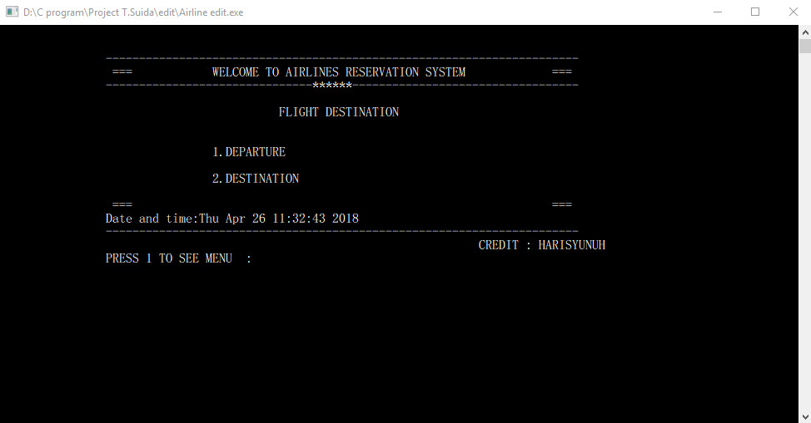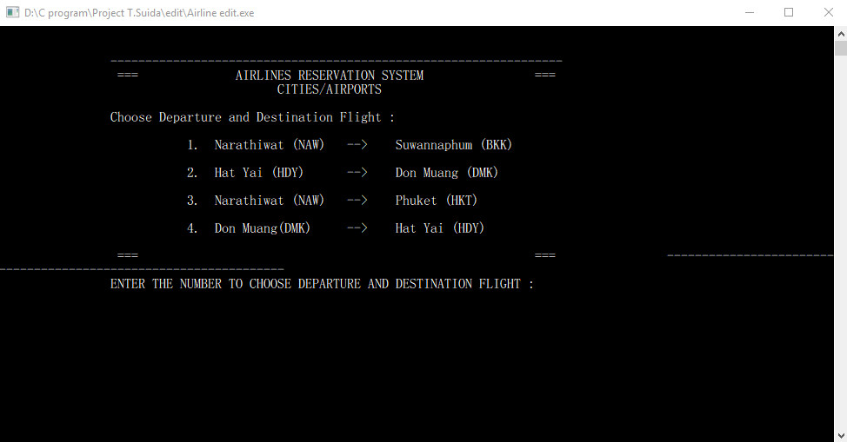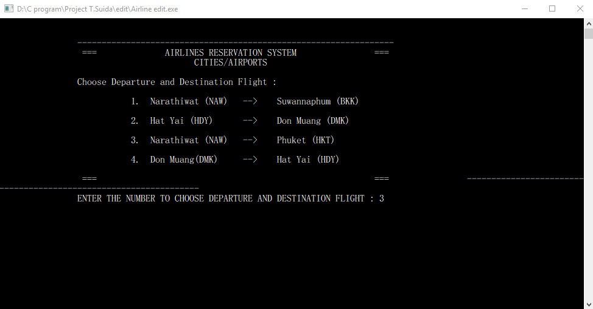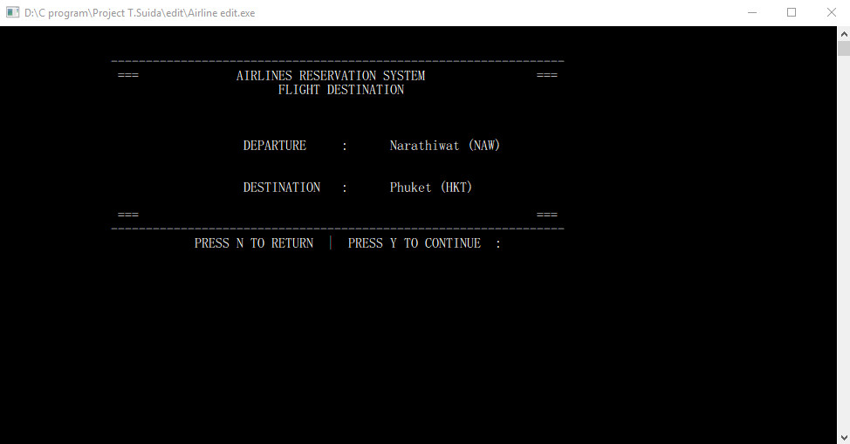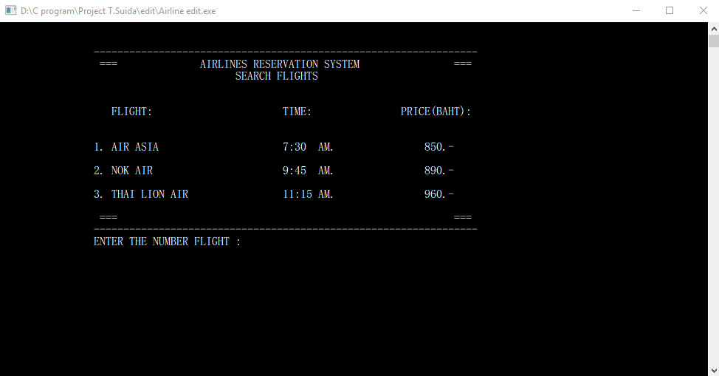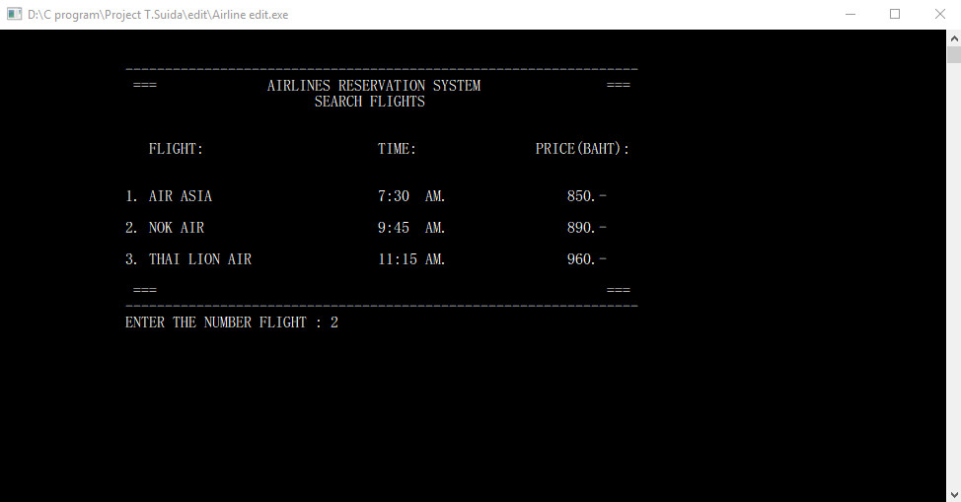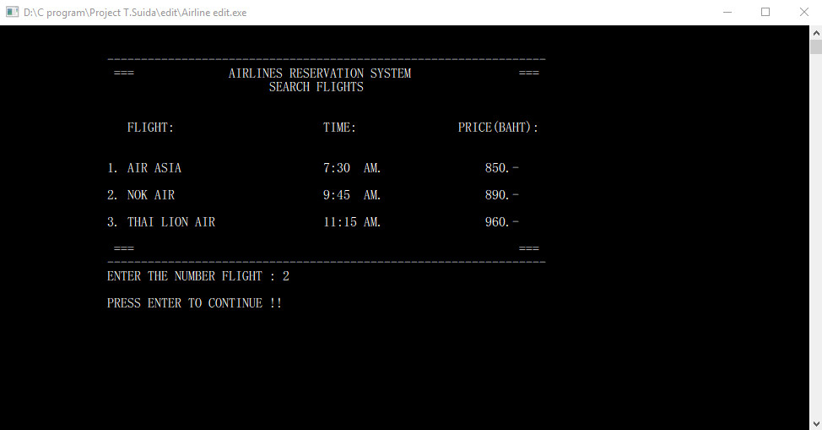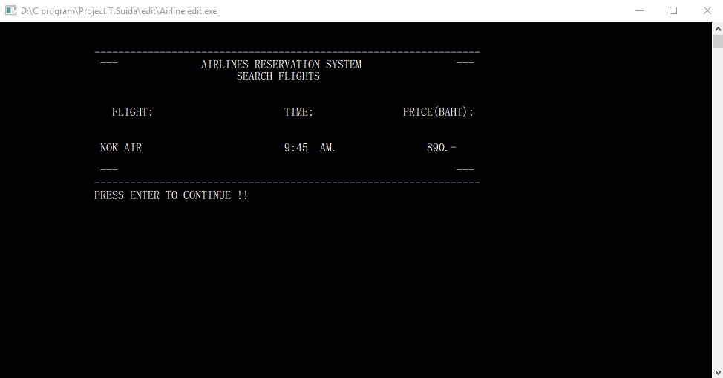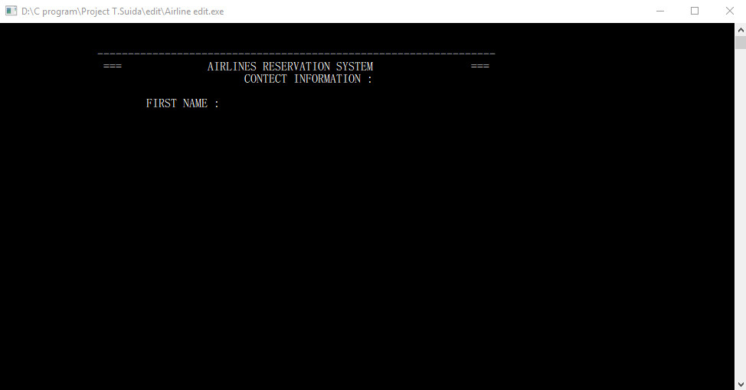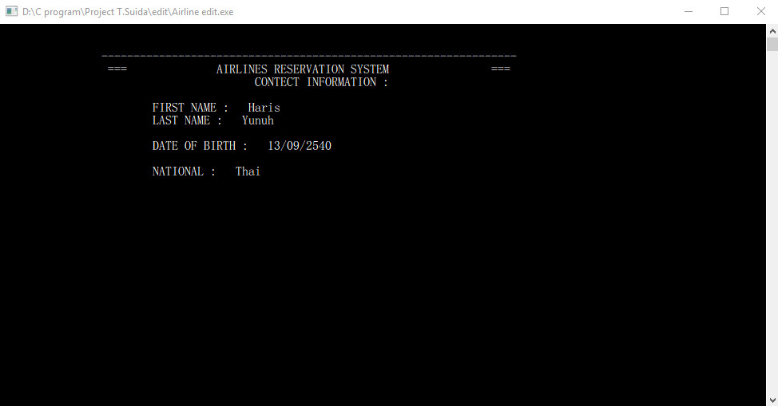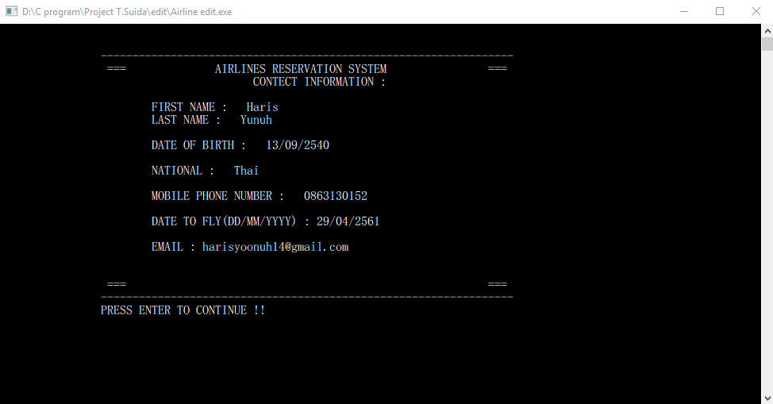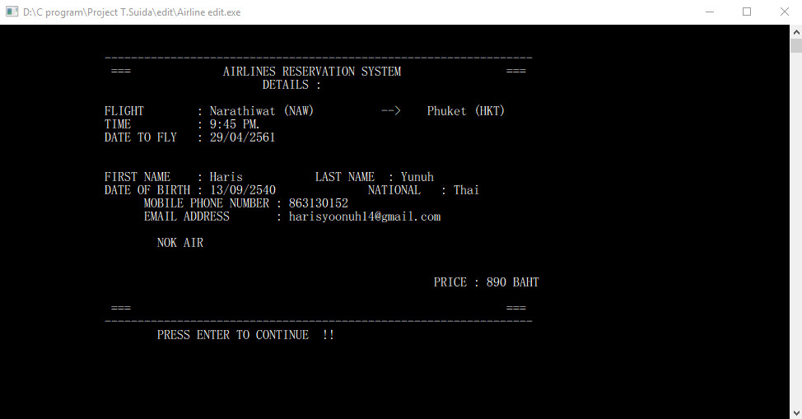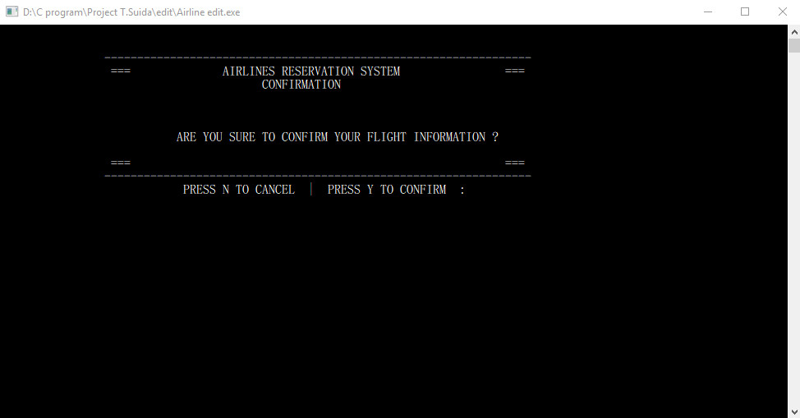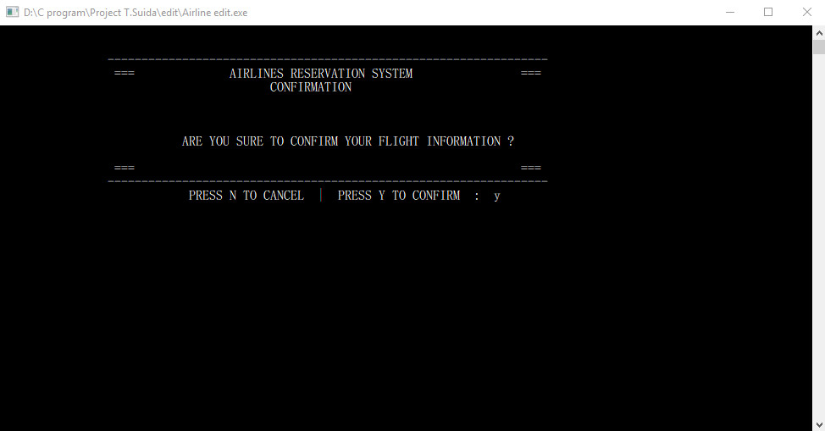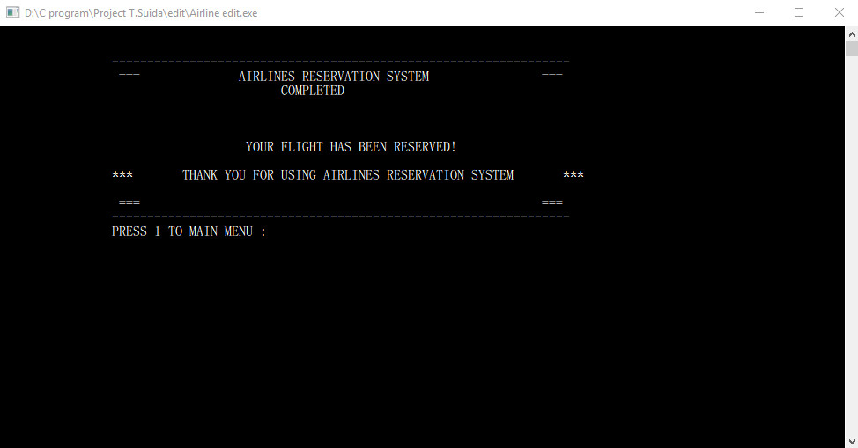

**Discussion and Program Limitations**

* In this program, I fix to show output passenger information and payment.
* If user type another numbers that I already set in the program, some page is got error and the program is blink.
* The program does not have file handling, so it cannot keep information that user entered.
* The program is not much departure and destination.
* The program is not perfect yet and I will develop it again, In Sha Allah.

**Summary**

The AIRLINES RESERVATION SYSTEM is a program for booking a flight in Thailand within 4 popular airlines fly across to 3 destination cities.

The passenger can choose departure and destination, then the passenger input information or details to reserve a flight.

**The flight booking will be completed by following these step:**

1. User chooses departure and destination flight.

2. User enters number of passenger.

3. User chooses airline.

4. User put information for booking.

5. User confirms the booking.

6. Done!

**References**

* Gautam Ghosh (2013), “C Introduction”.

See: <http://www.w3schools.in/c-tutorial/intro/>.

* Gautam Ghosh (2013), “control-statements”.

See: <https://www.cis.upenn.edu/~matuszek/General/JavaSyntax/control-statements.html>

* Gautam Ghosh (2013), “C If Statements”.

See: <https://www.programiz.com/c-programming/c-if-else-statement>

* Gautam Ghosh (2013), “C If-else Statements”.

See: <https://beginnersbook.com/2014/01/c-if-else-statement-example/>

* Gautam Ghosh (2013), “C Switch Statement”.

See: <http://www.w3schools.in/c-tutorial/decision-making/switch/>.

* Gautam Ghosh (2013), “C Loops”.

See: <http://www.w3schools.in/c-tutorial/loops/>.

* Gautam Ghosh (2013), “C Do-while loop”.

See: <http://www.w3schools.in/c-tutorial/loops/do-while/>.

* Gautam Ghosh (2013), “C for loop”.

See: <http://www.w3schools.in/c-tutorial/loops/for/>.

* Gautam Ghosh (2013), “C Functions”.

See: <https://www.cs.utah.edu/~germain/PPS/Topics/C_Language/c_functions.html>

* Gautam Ghosh (2013), “C Arrays and C Pointers”.

See: <http://www.w3schools.in/c-tutorial/arrays/>.

<http://www.w3schools.in/c-tutorial/pointers/>.

* Gautam Ghosh (2013), “file handling c”.

See: <https://www.geeksforgeeks.org/basics-file-handling-c/>